
DATA STRUCTURES AND ALGORITHMS
23CSE203 LAB
LAB MANUAL
Submitted by
Name | Rahul Gupta Devisetty
Roll No | AV.SC.U4CSE25028
Year\Sem\Section | 2nd Year\Sem-2\CSE - A
Credits | 05
GIT REPO Link | https://github.com/rahulgupthadevisetty-cmyk/DSA

Submitted to | Dr.Raj Kumar Batchu
Designation | Asst.Proffessor(S l. Grade)
Department | School of Computing

INDEX
S.No | Title | Date | Remarks
1. | 1a). AIM: Rocket launch systems display the countdown of before launch instead of using a loop to implement the countdown using the recursion. Write a recursion Python program to display the countdown from n to 1 followed by launch.  1b) AIM:Banks calculate the growth of an investment using compound interest. The formula requires calculating powers, which can be implemented recursively. Write a recursive Python program to calculate P^n (power), where P = Principal growth factor, n = number of years.  1c).AIM: An HR department stores employee IDs in a list. Develop a recursive program to search for a given employee ID. Write a recursive function to search for an employee ID in a list.  1d).AIM: In a logistics company, the number of possible ways to arrange different parcels is calculated using the factorial formula. Develop a recursive program to calculate the factorial of a given number.  1e).AIM:Write a recursive Python program to print the first n terms of a Fibonacci series. | 23-07-2026
2. | 2a).AIM: Write a Python program to perform linear search om the given input.  2b.1).AIM: Write a python program to perform binary search on the given input verify by taking sorted array as a input.  2b.2).AIM: Write a python program to perform binary search on the given input verify by taking Unsorted array as a input. | 30-07-2026
3. | 3a).AIM: Write a python program to sort the elements using a bubble sort technique. Take input elements from the user.  3b).AIM: Write a python program to sort the elements using a insertion sort technique. Take input elements from the user.  3c).AIM: Write a python program to sort the elements using a selection sort technique. Take input elements from the user.  3d).AIM: Write a python program to sort the elements using a merge sort technique. Take input elements from the user.  3e).AIM: Write a python program to sort the elements using a quick sort technique. Take input elements from the user. | 06-08-2026
4. | 4a).AIM: -Write a Python program to implement a Singly Linked List with the following operations:  1.Create a singly linked list with n nodes.  2. Insert a node at the beginning of the linked list.  3. Insert a node at the end of the linked list.  4. Insert a node at a specific position.  5. Delete a node by its value.  6. Delete the first node.  7. Delete the last node.  8. Count the number of nodes in the linked list.  9. Display/Traverse the linked list.  10. Exit the program.  4b).AIM:-To write a Python program to implement a Doubly Linked List and perform insertion, deletion, counting, and traversal operations in both forward and backward directions.  4c).AIM: -To write a Python program to implement a Circular Linked List and perform insertion, deletion, counting, and traversal operations. | 13-08-2026
5. | 5a).AIM: Write a Python Program Implement a Stack using Array also Implement the Stack Operations Such as Push, Pop,Peak also display the Stack Elements.  5b).AIM: Write a Python Program Implement a Stack using Linked List also Implement the Stack Operations Such as Push, Pop,Peak also display the Stack Elements. | 27-08-2026
6. | 6a).AIM: Write a Python Program to implement Queue and its operations such as In queue, Dequeue, Peek, Display with a Menu-driven approach implement using Array and Linked List data structure.  6b).AIM: Write a Python Program to implement Queue and its operations such as In queue, Dequeue, Peek, Display with a Menu-driven approach implement using Circular Queue. | 03-09-2026
7. | 7a.1).AIM: Write a Python Program to implement a binary tree using an array with all of its operations.  7a.2).AIM: Write a Python Program to implement a binary tree using an linked list with all of its operations. | 24-09-2026
8. | 8a).AIM: Write a Python Program to implement  Binary Search Tree with it's operations  Transversals also | 08-10-2026
9. | 9a).AIM:Write a Python Program to implement  AVL Tree with it's operations  Transversals also. | 22-10-2026
10. | 10a).AIM: Write a python program to implement hashing using seperate chaining linear and Quardtic Probic. | 29-10-2026

WEEK-1
1a).AIM: - rocket launch systems display the countdown of before launch instead of using a loop to implement the countdown using the recursion. Write a recursion Python program to display the countdown from n to 1 followed by launch.
PROGRAM: -
def countdown(n):
if n == 0:
print("Launch!")
else: print(n)
countdown(n - 1)
n = int(input("Enter countdown number: "))
countdown(n)
OUTPUT: -
Explanation:
1)def countdown(n): defines a function that receives a number.
2)if n == 0: checks whether the countdown has reached zero.
3)print("Launch!") prints Launch! when n becomes 0.
4) Else: Run when n is not zero.
5)print(n) displays the current number.
6)countdown (n - 1) calls the same function again with a number one smaller. This is called recursion.
7)The recursion continues until n == 0.
Errors Table:
S.No | Error | Explanation | Error
1. | Negative input |  | Check that n >= 0
  If the user enters -1, the function keeps calling itself: -1, -2, -3...
2. | Very Large input | Extremely large countdowns can eventually be impractical, and recursion has a depth limit. | Use a for/while loop for large values
3. | Non-integer input | Entering abc or 3.5 causes Value Error because of int(). | Validate input or use try/except
4. | Missing base case for negative numbers | The only stopping condition is n == 0; negative values never reach it. | Use if n <= 0: or reject negative input
5. | Recursive approach is unnecessary | Recursion consumes stack space for every countdown number. A loop is simpler and safer. | Use a loop for a normal countdown
Time Complexity: O(n)
Space Complexity: O(n)
Reason: Function is called once for each value from n to 0.

1b).AIM: - Banks calculate the growth of an investment using compound interest. The formula requires calculating powers, which can be implemented recursively. Write a recursive Python program to calculate P^n (power), where P = Principal growth factor, n = number of years.
PROGRAM: -
def power (p, n):
if n == 0:
return 1
else:
return p * power (p, n - 1)

p = int (input ("Enter principal growth factor: "))
n = int (input ("Enter number of years: "))

result = power (p, n)

print ("Power =", result)
OUTPUT: -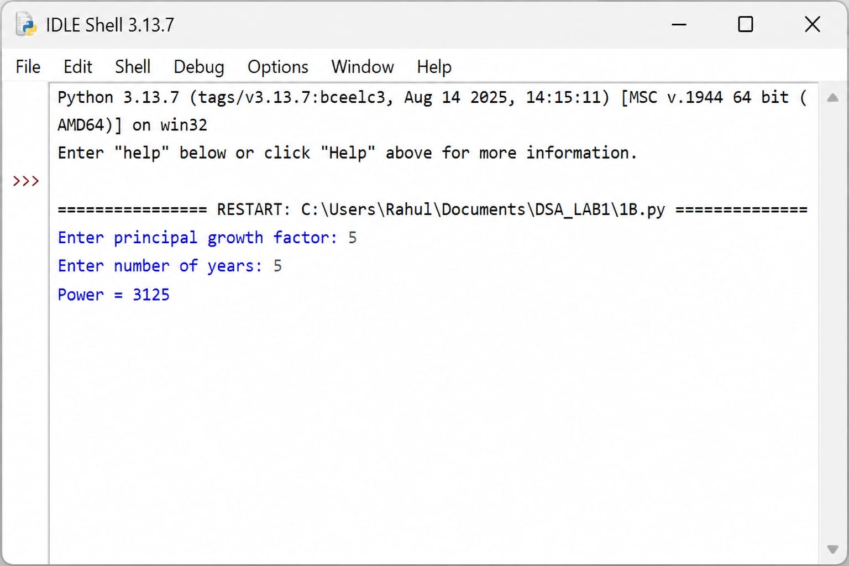Explanation:
1)power(p, n) is a recursive function.
2)If n == 0, it returns 1 because any number raised to power 0 is 1. 3)Otherwise, it returns p * power (p, n - 1).
4)p is the principal/growth factor.
5)n is the number of years.
6)The result is stored in result and printed.

Errors Table:
S.NO | Errors | Correction
1. | if n == 0: has no indentation for return 1 | Indent return 1
2. | return p * power(...) must be inside the else block | Indent it
3. | The line taking input for p is commented out with # | Remove #
4. | Because p input is commented, p is undefined when power(p,n) is called | Define p using input()
5. | The recursive function needs proper indentation throughout | Use consistent 4-space indentation
TIME COMPLEXITY: - O(n)
SPACE COMPLEXITY: - O(n)
REASON: - Recursive call is made n times to compute Pⁿ.

1c).AIM:- An HR department stores employee IDs in a list. Develop a recursive program to search for a given employee ID. Write a recursive function to search for an employee ID in a list.
PROGRAM:-
def search_employee(emp_list, emp_id, index=0):
if index == len(emp_list):
return -1
elif emp_list[index] == emp_id:
return index
else:
return search_employee(emp_list, emp_id, index + 1)

employee = [101, 102, 103, 104, 105]
search_id = int(input("Enter Employee ID to search: "))

position = search_employee(employee_ids, search_id)
if position != -1:
print("Employee ID", search_id, "found at position", position)
else:
print("Employee ID", search_id, "not found")
OUTPUT: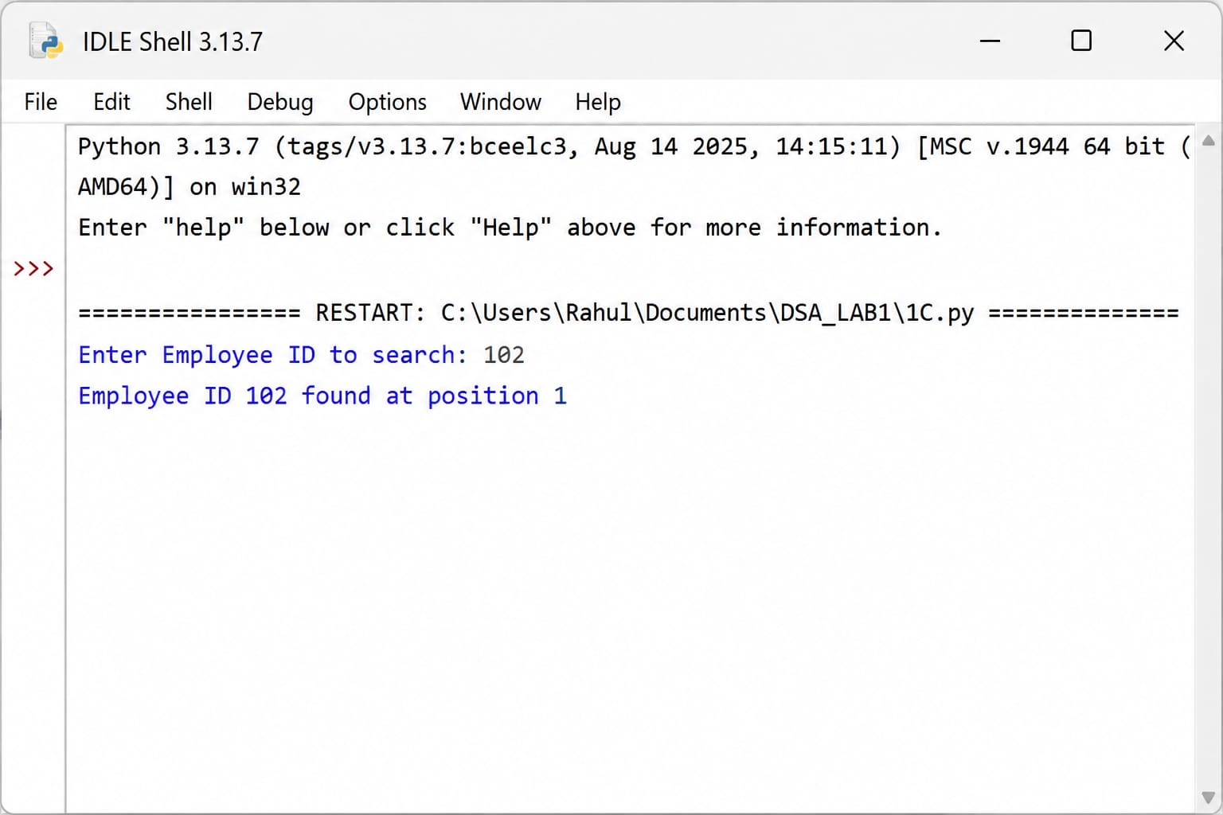Explanation:
1)search employee(emp_list, emp_id, index=0) defines a recursive function.
2)index starts at 0, meaning it checks the first employee ID.
3)if index == len(emp_list): checks whether the end of the list has been reached.
4)If the ID is found, return index gives its position.
5)Otherwise, the function calls itself with index + 1 to check the next employee.
6)-1 means the employee ID was not found.
7)The program asks the user to enter an employee ID and then searches for it.
Errors Table:
S.No | Errors | Correction
1. | if, elif, and else statements need proper indentation | Indent the statements inside the function
2. | Return -1 must be inside the if block | Add Indentation
3. | return index must be inside the elif block | Add Indentation
4. | Recursive return search_employee(...) must be inside the else block | Add Indentation
5. | employee_ids = [...] should not be part of the comment | Remove # before employee_ids
TIME COMPLEXITY:- O(n)
SPACE COMPLEXITY:- O(n)
REASON:- In the worst case, every element in the list is checked recursively.

1d).AIM:- In a logistics company, the number of possible ways to arrange n different parcels is calculated using the factorial formula. Develop a recursive program to calculate the factorial of a given number.
PROGRAM:
def factorial(n):
if n == 0 or n == 1:
return 1
else:
return n * factorial(n - 1)

n = int(input("Enter a number to find its factorial: "))

print("Factorial of", n, "is", factorial(n))
OUTPUT: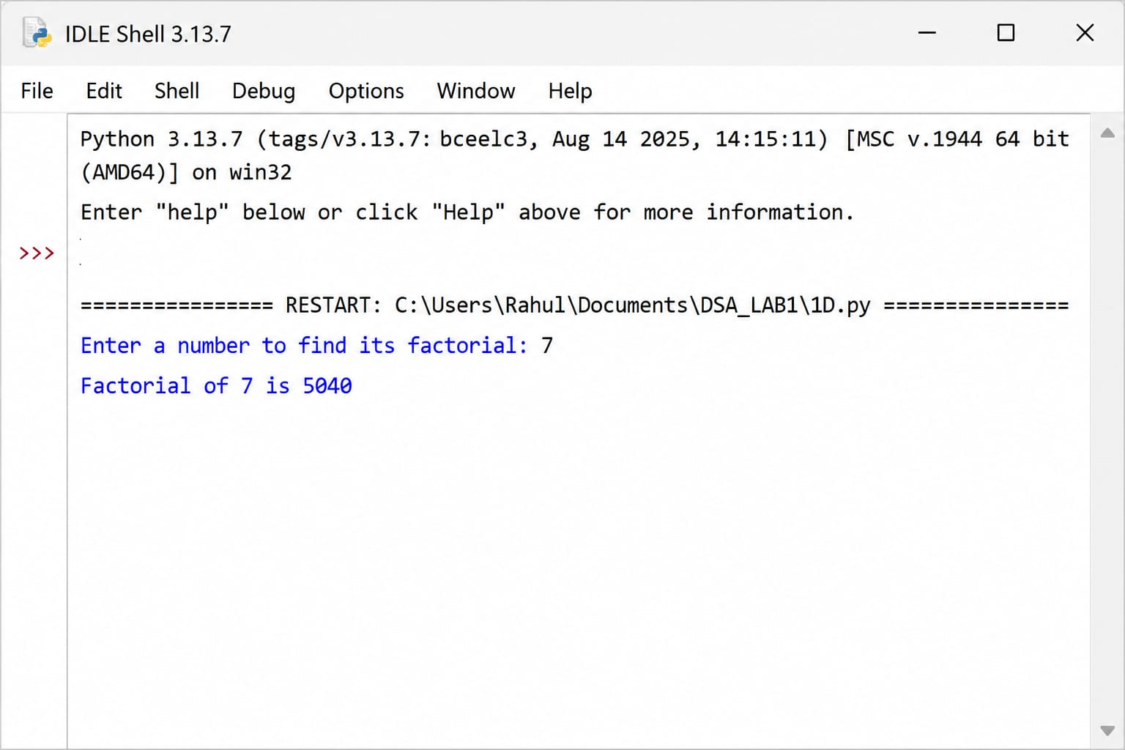
Explanation:
This program finds the factorial of a number using recursion.
- def factorial(n):
Defines a function named factorial that takes n as an argument.
- if n == 0 or n == 1:
Checks the base condition. The factorial of 0 and 1 is 1.
- return 1
Returns 1 when n is 0 or 1.
- else:
Executes when n is greater than 1.
- return n * factorial(n - 1)
The function calls itself with n - 1. This is called recursion.
- Input statement
The user enters a number, which is stored in n.
- Function call and output
factorial(n) calculates the factorial and the print() statement displays the result.
Errors Table:
S.No | Errors | Correction
1. | def factorial(n): must have its function body properly indented | indent the if statement
2. | return 1 must be inside the if block | Add proper indentation
3. | return n * factorial(n - 1) must be inside the else block | Add proper indentation
4. | n = int(input(...)) is commented out because of # | Remove #
5. | print(...) should be written as a separate executable statement | Remove the comment and place it outside the function
TIME COMPLEXITY:- O(n)
SPACE COMPLEXITY:- O(n)
REASON:- Function calls itself n times until reaching the base case.

1e).AIM:- Write a recursive Python program to print the first n terms of a Fibonacci series.
PROGRAM:-
def fibonacci(n):
if n == 0:
return 0
elif n == 1:
return 1
else:
return fibonacci(n - 1) + fibonacci(n - 2)

n = int(input("Enter the number of terms: "))

print("Fibonacci series:")
for i in range(n):
print(fibonacci(i), end=" ")
OUTPUT: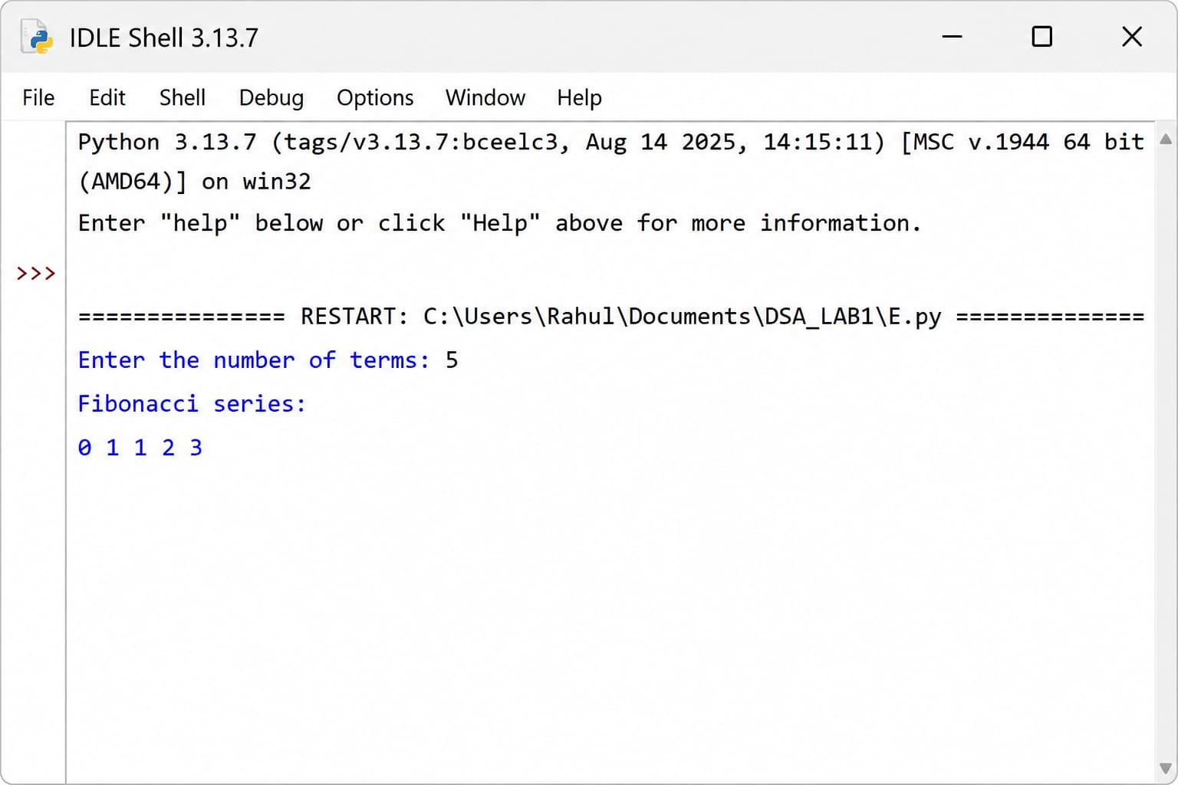

Explanation:
This program generates the Fibonacci series using recursion.
- def fibonacci(n):
Defines a function named fibonacci() that takes n as an argument.
- if n == 0:
Checks if n is 0. The first Fibonacci number is 0.
- return 0
Returns 0 when n is 0.
- elif n == 1:
Checks if n is 1. The second Fibonacci number is 1.
- return 1
Returns 1 when n is 1.
- else:
For numbers greater than 1, the function calculates the next Fibonacci number.
- return fibonacci(n - 1) + fibonacci(n - 2)
The function calls itself twice and adds the previous two Fibonacci numbers. This is recursion.
- Input
The user enters the number of terms to display.
- for i in range(n):
The loop runs n times and generates each Fibonacci term.
- print(fibonacci(i), end=" ")
Prints each Fibonacci number on the same line.

Errors Table:
S.No | Errors | Correction
1. | if n == 0: must be properly indented inside the function | Indent it
2. | return 0 must be inside the if block | Add indentation
3. | return 1 must be inside the elif block | Add indentation
4. | return fibonacci(n - 1) + fibonacci(n - 2) must be inside the else block | Add indentation
5. | n = int(input(...)) is commented out because of # | Remove #

TIME COMPLEXITY:- O(2n)
SPACE COMPLEXITY:- O(n)
REASON:- Each call creates two recursive calls, resulting in exponential time, while the recursion depth is n.

WEEK-2
2a).AIM: Write a Python program to perform linear search om the given input.
PROGRAM:
def linear_search(arr, target):
for i in range(len(arr)):
if arr[i] == target:
return i
return -1

arr = [10, 20, 30, 40, 50]
target = int(input("Enter the element to search: "))

position = linear_search(arr, target)

if position != -1:
print("Element", target, "found at position", position)
else:
print("Element", target, "not found")
OUTPUT: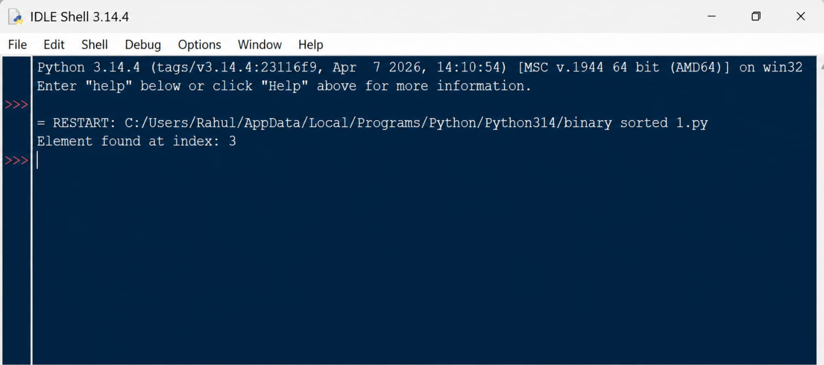

Explanation:
1)linear search(arr, target) defines the search function. 2)for i in range(len(arr)) goes through every element of the list.
3)if arr[i] == target compares the current element with the target.
4)If the element matches, return i returns its position.
5)If the loop finishes without finding the element, return -1 indicates that the element is not present.
6)The user enters the element to search.
7)The if statement checks whether the returned position is -1.
8)Finally, the program prints whether the element was found or not.
Error Table:
S.No | Errors | Correction
1. | Writing arr[i] = target instead of arr[i] == target | Use == for comparison
2. | Forgetting return i when the element is found | Add return i inside the if block
3. | Forgetting return -1 after the loop | Add it to indicate "not found"
4. | Incorrect indentation inside the for or if block | Use proper indentation
5. | Using range(len(arr) - 1) | Use range(len(arr)) so the last element is also checked
Time Complexity: O(n)
Space Complexity: O(1)
Reason: The algorithm does not create another list or data structure. It only uses a few variables such as i, arr, and target.

2b.1) AIM: Write a python program to perform binary search on the given input verify by taking sorted array as a input.
PROGRAM:
def binary_search(arr, target):
low = 0
high = len(arr) - 1
while low <= high:
mid = (low + high) // 2
if arr[mid] == target:
return mid
elif arr[mid] < target:
low = mid + 1
else:
high = mid – 1
return -1

arr = [10, 20, 30, 40, 50, 60, 70]
target = int(input("Enter the element to search: "))
# Function call
position = binary_search(arr, target)

if position!= -1:
print ("Element", target, "found at position", position)
else:
print ("Element", target, "not found")
OUTPUT: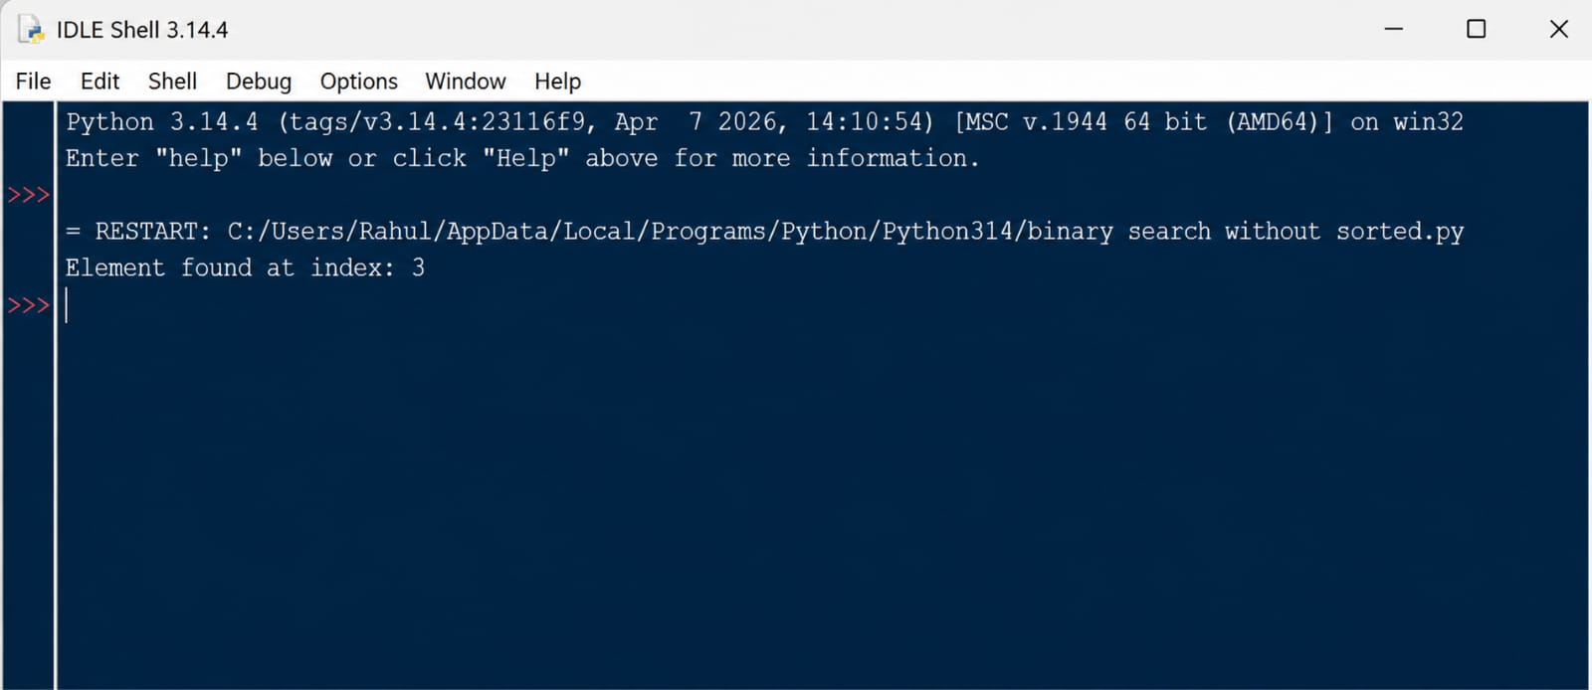
Explanation:
1)Set low to the first position.
2)Set high to the last position.
3)Find the middle position using (low + high) // 2.
4)If the middle element equals the target, return its position.
5)If the target is greater than the middle element, search the right half.
6)If the target is smaller, search the left half.
7)Continue until the element is found or the search range becomes empty.
Errors Table:
S.No | Explanation | Errors
1. | Using an unsorted list | Use a sorted list
2. | Writing mid = (low + high) / 2 | Use // 2
3. | Using low = mid when searching right | Use low = mid + 1
4. | Using high = mid when searching left | Use high = mid - 1
5. | Forgetting return -1 | Add it after the loop
Time Complexity: O(n)
Space Complexity: O(1)
Reason: Binary search eliminates approximately half of the elements in every step.
2b.2) AIM: Write a python program to perform binary search on the given input verify by taking Unsorted array as a input.
PROGRAM:
def binary_search(arr, target):
low = 0
high = len(arr) - 1

while low <= high:
mid = (low + high) // 2

if arr[mid] == target:
return mid
elif arr[mid] < target:
low = mid + 1
else:
high = mid - 1

return -1

# Input
arr = [50, 20, 70, 10, 40, 60, 30]

target = int(input("Enter the element to search: "))

# Sort the array
arr.sort()

# Function call
position = binary_search(arr, target)

# Output
print("Sorted array:", arr)

if position != -1:
print("Element", target, "found at position", position)
else:
print("Element", target, "not found")

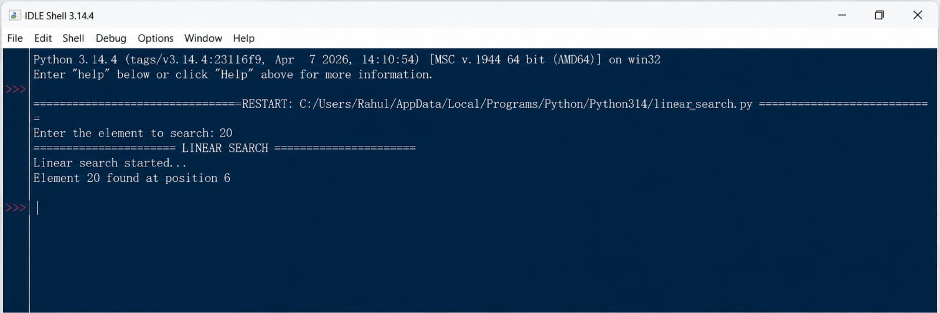
Explanation:
1)The original list is unsorted.
2)arr.sort() sorts the list in ascending order.
3)Binary search is then performed on the sorted list.
4)The middle element is checked.
5)If the target is larger, the search moves to the right half.
6 )If the target is smaller, the search moves to the left half.
7)The process continues until the element is found.
Errors Table:
S.No | Errors | Correction
1 | Binary search requires a sorted array | arr.sort() is correctly used before calling binary_search().
2 | low must start from the first index | Use low = 0.
3 | high must represent the last index | Use high = len(arr) - 1.
4 | The search range must be updated after each comparison | Use low = mid + 1 or high = mid - 1.
5 | Position returned by Python is 0-based index, not the human-readable position | For actual position, use position + 1 when displaying the result.
Time Complexity: O(n log n)
Space Complexity: O(n)
Reason: The sorting step dominates the total time. Binary search itself is only O(log n), but an unsorted list must first be sorted.

WEEK-3
3a).AIM: Write a python program to sort the elements using a bubble sort technique. Take input elements from the user.
PROGRAM:
n = int(input("Enter the number of elements: "))
arr = []
for i in range(n):
element = int(input(f"Enter element {i + 1}: "))
arr.append(element)
for i in range(n - 1):
for j in range(n - 1 - i):
if arr[j] > arr[j + 1]:
arr[j], arr[j + 1] = arr[j + 1], arr[j]
print ("Sorted elements:", arr)
OUTPUT: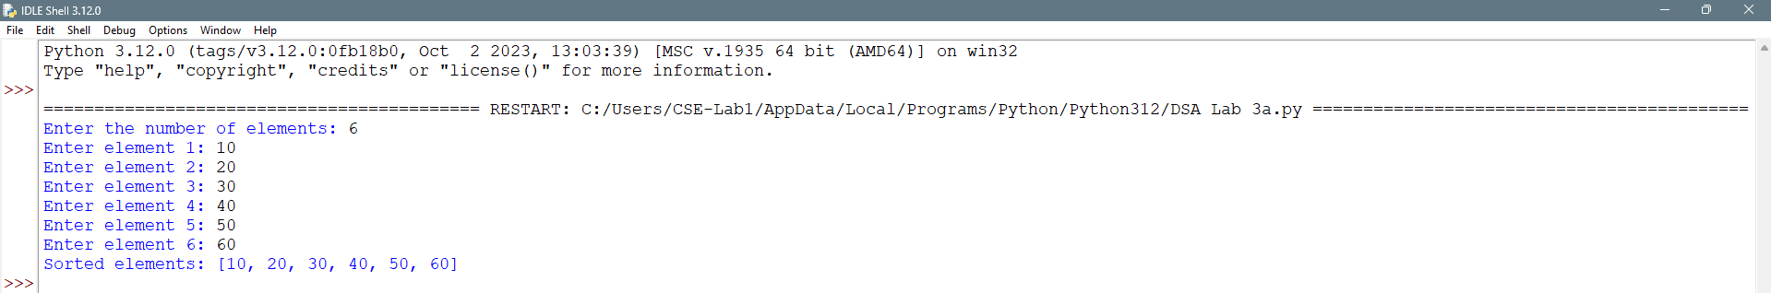
Explanation:
- n stores the number of elements to be entered.
- arr = [] creates an empty list to store the elements.
- The first for loop takes n numbers from the user.
- arr.append(element) adds each number to the list.
- The program uses the Bubble Sort technique to sort the elements.
- The outer loop controls the number of passes through the list.
- The inner loop compares adjacent elements.
- If arr[j] > arr[j+1], the two elements are swapped.
- After each pass, the largest element moves to the end of the list.
- Finally, print() displays the elements in ascending order.
Errors Table:
S.No | Errors | Correction
1 | for i in range(n): has extra indentation | Align it with arr = [].
2 | for i in range(n - 1): has extra indentation | Align it with the first for loop.
3 | The inner for j loop is not properly indented under the outer loop | Indent it by 4 spaces inside the outer for loop.
4 | if arr[j] > arr[j + 1]: must be inside the inner loop | Indent the if statement by 4 spaces under the for j loop.
5 | print("Sorted elements:", arr) has extra indentation | Place it at the left margin, outside all loops.

Time Complexity: O(n log n)
Space Complexity: O(n)
Reason: The sorting step dominates the total time. Binary search itself is only O(log n), but an unsorted list must first be sorted.

3b)AIM: Write a python program to sort the elements using a insertion sort technique. Take input elements from the user.
PROGRAM:
n = int(input("Enter the number of elements: "))
arr = []
for i in range(n):
element = int(input(f"Enter element {i + 1}: "))
arr.append(element)
for i in range(1, n):
key = arr[i]
j = i - 1
while j >= 0 and arr[j] > key:
arr[j + 1] = arr[j]
j = j - 1
arr[j + 1] = key
print("Sorted elements:", arr)
OUTPUT:
Explanation:
- n takes the number of elements from the user.
- arr = [] creates an empty list to store the elements.
- The first for loop reads each element from the user.
- arr.append(element) adds each element to the list.
- The second for loop starts from the second element (i = 1).
- key = arr[i] stores the current element that needs to be placed correctly.
- j = i - 1 points to the element before the key.
- The while loop compares the key with previous elements and shifts larger elements to the right.
- arr[j + 1] = key places the key in its correct position.
- Finally, print() displays the list in ascending order.

Errors Table:
S.No | Errors | Correction
1 | for i in range(n): has extra indentation | Align it with arr = [].
2 | for i in range(1, n): has extra indentation | Align it with the first for loop.
3 | while j >= 0 and arr[j] > key: is incorrectly indented | Indent it inside the for i loop.
4 | arr[j + 1] = arr[j] and j = j - 1 are not properly indented | Indent them inside the while loop.
5 | arr[j + 1] = key and print() have incorrect indentation | arr[j + 1] = key should be inside the for loop but outside while; print() should be outside the loop.

Time Complexity: O(n log n)
Space Complexity: O(n)
Reason: The sorting step dominates the total time. Binary search itself is only O(log n), but an unsorted list must first be sorted.

3c).AIM: Write a python program to sort the elements using a selection sort technique. Take input elements from the user.
PROGRAM:
n = int(input("Enter the number of elements: "))
arr = []
for i in range(n):
element = int(input(f"Enter element {i + 1}: "))
arr.append(element)
for i in range(n - 1):
min_index = i
for j in range(i + 1, n):
if arr[j] < arr[min_index]:
min_index = j
arr[i], arr[min_index] = arr[min_index], arr[i]
print ("Sorted elements:", arr)
OUTPUT:
Explanation:
- The program first asks the user to enter the number of elements and stores them in an array.
- It uses a for loop to take each element as input.
- The program uses the Selection Sort method to sort the elements.
- In each iteration, min_index stores the index of the smallest element.
- The inner loop compares the current element with the remaining elements.
- If a smaller element is found, its index is stored in min_index.
- The smallest element is then swapped with the element at the current position.
- This process continues until all elements are sorted.
- Finally, the sorted array is displayed using the print() statement.
Errors Table:
S.No | Errors | Correction
1 | for i in range(n - 1): has extra indentation | Align it with the first for i in range(n): loop.
2 | min_index = i is not properly indented | Indent it inside the for i loop.
3 | for j in range(i + 1, n): has incorrect indentation | Indent it inside the outer for i loop.
4 | if arr[j] < arr[min_index]: and min_index = j have incorrect indentation | Indent them properly inside the for j loop.
5 | arr[i], arr[min_index] = arr[min_index], arr[i] has incorrect indentation | Place it inside the outer for i loop, after the inner for j loop.

Time Complexity: O(n log n)
Space Complexity: O(n)
Reason: The sorting step dominates the total time. Binary search itself is only O(log n), but an unsorted list must first be sorted.

3D) AIM: Write a python program to sort the elements using a merge sort technique. Take input elements from the user.
PROGRAM:
def merge sort(arr):
if len(arr) > 1:
mid = len(arr) //
left = arr[:mid]
right = arr[mid:]
merge sort(left)
merge sort(right)
i = 0
j = 0
k = 0
while i < len(left) and j < len(right):
if left[i] < right[j]:
arr[k] = left[i]
i += 1
else:
arr[k] = right[j]
j += 1
k += 1
while i < len(left):
arr[k] = left[i]
i += 1
k += 1
while j < len(right):
arr[k] = right[j]
j += 1
k += 1
n = int(input("Enter the number of elements: "))
arr = []
for i in range(n):
element = int (input (f"Enter element {i + 1}: "))
arr.append(element)
merge sort(arr)
print("Sorted elements:", arr)
OUTPUT:
Explanation:
1)The original list is unsorted.
2)arr.sort() sorts the list in ascending order.
3)Binary search is then performed on the sorted list.
4)The middle element is checked.
5)If the target is larger, the search moves to the right half.
6 )If the target is smaller, the search moves to the left half.
7)The process continues until the element is found.

Errors Table:
S.No | Errors | Correction
1 | def merge sort(arr): contains a space in the function name | Use def merge_sort(arr):
2 | mid = len(arr) // is incomplete | Use mid = len(arr) // 2
3 | merge sort(left) and merge sort(right) contain spaces | Use merge_sort(left) and merge_sort(right)
4 | merge sort(left) and merge sort(right) are incorrectly indented | Indent both statements inside the if len(arr) > 1: block.
5 | merge sort(arr) at the end contains a space | Use merge_sort(arr)
Time Complexity: O(n log n)
Space Complexity: O(n)
Reason: The sorting step dominates the total time. Binary search itself is only O(log n), but an unsorted list must first be sorted.

3E).AIM: Write a python program to sort the elements using a quick sort technique. Take input elements from the user.
PROGRAM:
def quick_sort(arr):
if len(arr) <= 1:
return arr
pivot = arr[-1]
left = []
right = []
for element in arr[:-1]:
if element <= pivot:
left.append(element)
else:
right.append(element)
return quick_sort(left) + [pivot] + quick_sort(right)
n = int(input("Enter the number of elements: "))
arr = []
for i in range(n):
element = int(input(f"Enter element {i + 1}: "))
arr.append(element)
arr = quick_sort(arr)
print("Sorted elements:", arr)
OUTPUT:

Explanation:
- The quick_sort() function sorts the given list using the Quick Sort algorithm.
- If the list has one or zero elements, it is already sorted, so it is returned directly.
- The last element of the list is selected as the pivot.
- Elements smaller than or equal to the pivot are placed in the left list, while larger elements go into the right list.
- Quick Sort is then recursively applied to both left and right lists.
- Finally, the sorted left list, pivot, and sorted right list are combined.
- The program takes the number of elements and their values from the user.
- It calls quick_sort() and prints the sorted elements.

Errors Table:
S.No | Errors | Correction
1 | pivot = arr[-1] is not properly indented | Indent it inside the quick_sort() function.
2 | right = [] has incorrect indentation | Align it with left = [].
3 | for element in arr[:-1]: and its if-else block have inconsistent indentation | Use proper 4-space indentation throughout the loop.
4 | return quick_sort(left) + [pivot] + quick_sort(right) is incorrectly indented | Place it inside quick_sort() but outside the for loop.
5 | The main program (n = int(input(...)) onward) is incorrectly indented | Keep the main program outside the quick_sort() function, at the left margin.
Time Complexity: O(n log n)
Space Complexity: O(n)
Reason: The sorting step dominates the total time. Binary search itself is only O(log n), but an unsorted list must first be sorted.

WEEK – 4
4a).AIM: -Write a Python program to implement a Singly Linked List with the following operations:
- Create a singly linked list with n nodes.
- Insert a node at the beginning of the linked list.
- Insert a node at the end of the linked list.
- Insert a node at a specific position.
- Delete a node by its value.
- Delete the first node.
- Delete the last node.
- Count the number of nodes in the linked list.
- Display/Traverse the linked list.
- Exit the program.
Implement the above operations using a menu-driven program and a Node class.
PROGRAM: -
class Node: def init(self, data): self.data = data self.next = None
class SinglyLinkedList: def init(self): self.head = None
def create(self):
n = int(input("Enter number of nodes: "))
if n <= 0:
print("Number of nodes must be greater than 0.")
return
for i in range(n):
data = int(input(f"Enter data for node {i + 1}: "))
new_node = Node(data)
if self.head is None:
self.head = new_node
else:
temp = self.head
while temp.next is not None:
temp = temp.next
temp.next = new_node
print("Linked List created successfully.")
def insert_beginning(self, data):
new_node = Node(data)
new_node.next = self.head
self.head = new_node
print("Node inserted successfully.")
def insert_end(self, data):
new_node = Node(data)
if self.head is None:
self.head = new_node
print("Node inserted successfully.")
return
temp = self.head
while temp.next is not None:
temp = temp.next
temp.next = new_node
print("Node inserted successfully.")
def insert_at_position(self, data, position):
if position < 1:
print("Invalid position.")
return
new_node = Node(data)
if position == 1:
new_node.next = self.head
self.head = new_node
print("Node inserted successfully.")
return
temp = self.head
for i in range(position - 2):
if temp is None:
print("Invalid position.")
return
temp = temp.next
if temp is None:
print("Invalid position.")
return
new_node.next = temp.next
temp.next = new_node
print("Node inserted successfully.")
def delete_by_value(self, value):
if self.head is None:
print("Linked List is empty.")
return
if self.head.data == value:
self.head = self.head.next
print("Node deleted successfully.")
return
temp = self.head
while temp.next is not None:
if temp.next.data == value:
temp.next = temp.next.next
print("Node deleted successfully.")
return
temp = temp.next
print("Value not found.")
def delete_first(self):
if self.head is None:
print("Linked List is empty.")
return
deleted_value = self.head.data
self.head = self.head.next
print("First node deleted:", deleted_value)
def delete_last(self):
if self.head is None:
print("Linked List is empty.")
return
if self.head.next is None:
deleted_value = self.head.data
self.head = None
print("Last node deleted:", deleted_value)
return
temp = self.head
while temp.next.next is not None:
temp = temp.next
deleted_value = temp.next.data
temp.next = None
print("Last node deleted:", deleted_value)
def count_nodes(self):
count = 0
temp = self.head
while temp is not None:
count += 1
temp = temp.next
print("Number of nodes:", count)
def display(self):
if self.head is None:
print("Linked List is empty.")
return
temp = self.head
print("Linked List:")
while temp is not None:
print(temp.data, end=" -> ")
temp = temp.next
print("None")
sll = SinglyLinkedList()
while True: print("\n======================================") print(" SINGLY LINKED LIST") print("======================================")
print("1. Create Linked List")
print("2. Insert at beginning")
print("3. Insert at end")
print("4. Insert at specific position")
print("5. Delete by value")
print("6. Delete First Node")
print("7. Delete Last Node")
print("8. Count no of nodes")
print("9. Display / Traverse")
print("10. Exit")
print("======================================")
ch = int(input("Enter your choice: "))
if ch == 1:
sll.create()
elif ch == 2:
data = int(input("Enter data: "))
sll.insert_beginning(data)
elif ch == 3:
data = int(input("Enter data: "))
sll.insert_end(data)
elif ch == 4:
data = int(input("Enter data: "))
position = int(input("Enter position (starting from 1): "))
sll.insert_at_position(data, position)
elif ch == 5:
value = int(input("Enter value to delete: "))
sll.delete_by_value(value)
elif ch == 6:
sll.delete_first()
elif ch == 7:
sll.delete_last()
elif ch == 8:
sll.count_nodes()
elif ch == 9:
sll.display()
elif ch == 10:
print("Exiting program...")
break
else:
print("Invalid choice. Please enter a number between 1 and 10.")

OUTPUT:
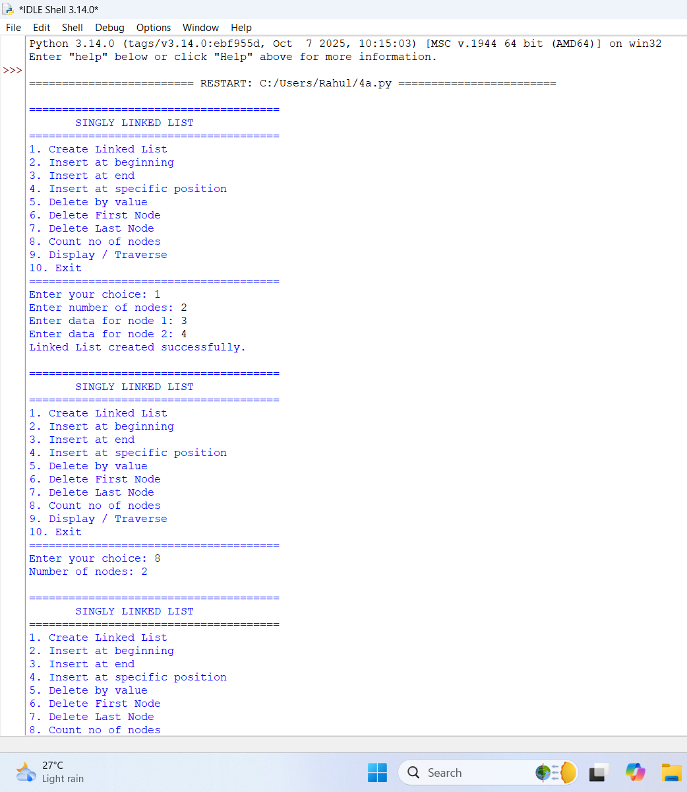

Explanation:
- The program implements a Singly Linked List using Node and Singly LinkedList classes.
- Each node contains data and a next pointer that stores the reference to the next node.
- The head points to the first node of the linked list.
- The program supports insertion at the beginning, end, and a specific position.
- It supports deletion by value, from the beginning, and from the end.
- The count nodes() function counts the total number of nodes.
- The display () function traverses and prints all nodes in the list.
- A menu-driven program is used to allow the user to select different operations.

Error Table:
S.NO | Errors | Correction
1. | def init(self, data): | Change to def __init__(self, data):
2. | def init(self): | Change to def __init__(self):
3. | Incorrect indentation in create () | Maintain proper 4-space indentation inside the method.
4. | print("Node inserted successfully.") in insert_end() has incorrect indentation | Align it properly with the other statements in the method.
5. | Menu statements after while True: are not properly indented | Align it properly with the other statements in the method.

4b).AIM:-To write a Python program to implement a Doubly Linked List and perform insertion, deletion, counting, and traversal operations in both forward and backward directions.
PROGRAM: -
class Node: def init(self, data): self.data = data self.prev = None self.next = None
class DoublyLinkedList: def init(self): self.head = None
def create(self):
n = int(input("Enter number of nodes: "))
if n <= 0:
print ("Number of nodes must be greater than 0.")
return
for i in range(n):
data = int(input(f"Enter data for node {i + 1}: "))
new_node = Node(data)
if self.head is None:
self.head = new_node
else:
temp = self.head
while temp.next is not None:
temp = temp.next
temp.next = new_node
new_node.prev = temp
print("Linked List created successfully.")
def insert_beginning(self):
data = int(input("Enter data: "))
new_node = Node(data)
if self.head is None:
self.head = new_node
else:
new_node.next = self.head
self.head.prev = new_node
self.head = new_node
print("Node inserted at beginning.")
def insert_end(self):
data = int(input("Enter data: "))
new_node = Node(data)
if self.head is None:
self.head = new_node
else:
temp = self.head
while temp.next is not None:
temp = temp.next
temp.next = new_node
new_node.prev = temp
print("Node inserted at end.")
def insert_position(self):
position = int(input("Enter position: "))
data = int(input("Enter data: "))
if position <= 0:
print("Invalid position.")
return
new_node = Node(data)
# Insert at beginning
if position == 1:
if self.head is not None:
new_node.next = self.head
self.head.prev = new_node
self.head = new_node
print("Node inserted.")
return
temp = self.head
for i in range(position - 2):
if temp is None:
print("Position does not exist.")
return
temp = temp.next
if temp is None:
print("Position does not exist.")
return
new_node.next = temp.next
new_node.prev = temp
if temp.next is not None:
temp.next.prev = new_node
temp.next = new_node
print("Node inserted.")
def delete_by_value(self):
value = int(input("Enter value to delete: "))
temp = self.head
while temp is not None:
if temp.data == value:
# If first node
if temp.prev is None:
self.head = temp.next
if self.head is not None:
self.head.prev = None
else:
temp.prev.next = temp.next
if temp.next is not None:
temp.next.prev = temp.prev
print("Node deleted.")
return
temp = temp.next
print("Value not found.")
def delete_first(self):
if self.head is None:
print("Linked List is empty.")
return
self.head = self.head.next
if self.head is not None:
self.head.prev = None
print("First node deleted.")
def delete_last(self):
if self.head is None:
print("Linked List is empty.")
return
temp = self.head
while temp.next is not None:
temp = temp.next
# Only one node
if temp.prev is None:
self.head = None
else:
temp.prev.next = None
print("Last node deleted.")
def count(self):
count = 0
temp = self.head
while temp is not None:
count += 1
temp = temp.next
print("Number of nodes:", count)
def display_forward(self):
if self.head is None:
print("Linked List is empty.")
return
temp = self.head
print("Forward:", end=" ")
while temp is not None:
print(temp.data, end=" <-> ")
temp = temp.next
print("None")
def display_backward(self):
if self.head is None:
print("Linked List is empty.")
return
temp = self.head
# Move to last node
while temp.next is not None:
temp = temp.next
print("Backward:", end=" ")
while temp is not None:
print(temp.data, end=" <-> ")
temp = temp.prev
print("None")
dll = DoublyLinkedList()
while True:
print("\n======================================")
print(" DOUBLY LINKED LIST")
print("======================================")
print("1. Create Linked List")
print("2. Insert at beginning")
print("3. Insert at end")
print("4. Insert at specific position")
print("5. Delete by value")
print("6. Delete First Node")
print("7. Delete Last Node")
print("8. Count no of nodes")
print("9. Display Forward")
print("10. Display Backward")
print("11. Exit")
print("======================================")
choice = int(input("Enter your choice: "))
if choice == 1:
dll.create()
elif choice == 2:
dll.insert_beginning()
elif choice == 3:
dll.insert_end()
elif choice == 4:
dll.insert_position()
elif choice == 5:
dll.delete_by_value()
elif choice == 6:
dll.delete_first()
elif choice == 7:
dll.delete_last()
elif choice == 8:
dll.count()
elif choice == 9:
dll.display_forward()
elif choice == 10:
dll.display_backward()
elif choice == 11:
print("Program ended.")
break
else:
print("Invalid choice.")

OUTPUT: -
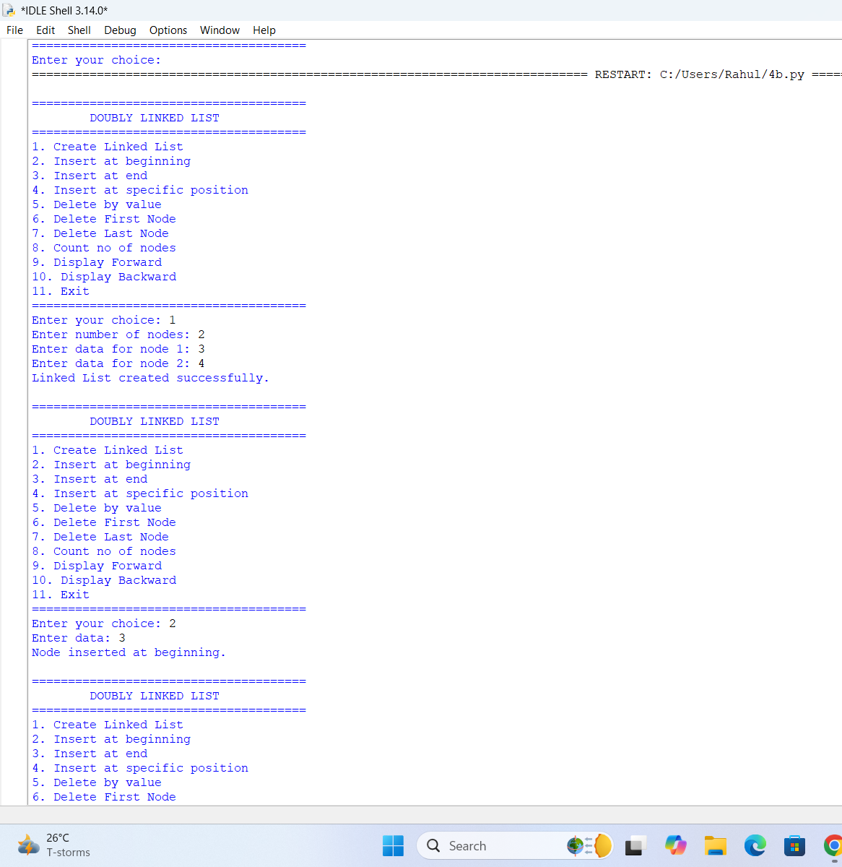

Explanation:
- The program implements a Doubly Linked List using a Node class.
- Each node contains data, prev, and next references.
- The head points to the first node of the list.
- Nodes can be inserted at the beginning, end, or a specific position.
- Nodes can be deleted by value, from the beginning, or from the end.
- The program counts the nodes and displays the list in forward and backward directions.

Error Table:
S.No | Errors | Correction
1 | def **init**(self, data) is incorrect | Change it to def __init__(self, data):
2 | def **init**(self) is incorrect | Change it to def __init__(self):
3 | if n <= 0: is not properly indented inside create() | Indent it by 4 spaces so it belongs to the create() method.
4 | The statements after while True: in the main program are not indented | Indent the complete menu and if-elif-else block inside the while True: loop.
5 | print("Invalid choice.") must be inside the else: block | Indent it by 4 spaces under else:.

4c).AIM: -To write a Python program to implement a Circular Linked List and perform insertion, deletion, counting, and traversal operations.
PROGRAM: -
class Node: def init(self, data): self.data = data self.next = None
class CircularLinkedList: def init(self): self.head = None
def create(self):
n = int(input("Enter number of nodes: ")) if n <= 0:
print("Number of nodes must be greater than 0.")
return
for i in range(n):
data = int(input(f"Enter data for node {i + 1}: "))
new_node = Node(data)
if self.head is None:
self.head = new_node
new_node.next = self.head
else:
temp = self.head
while temp.next != self.head:
temp = temp.next
temp.next = new_node
new_node.next = self.head
print("Circular Linked List created successfully.")
def insert_beginning(self):
data = int(input("Enter data: "))
new_node = Node(data)
if self.head is None:
self.head = new_node
new_node.next = self.head
else:
temp = self.head
while temp.next != self.head:
temp = temp.next
new_node.next = self.head
temp.next = new_node
self.head = new_node
print("Node inserted at beginning.")
def insert_end(self):
data = int(input("Enter data: "))
new_node = Node(data)
if self.head is None:
self.head = new_node
new_node.next = self.head
else:
temp = self.head
while temp.next != self.head:
temp = temp.next
temp.next = new_node
new_node.next = self.head
print("Node inserted at end.")
def insert_position(self):
position = int(input("Enter position: "))
data = int(input("Enter data: "))
if position <= 0:
print("Invalid position.")
return
# Position 1
if position == 1:
new_node = Node(data)
if self.head is None:
self.head = new_node
new_node.next = self.head
else:
temp = self.head
while temp.next != self.head:
temp = temp.next
new_node.next = self.head
temp.next = new_node
self.head = new_node
print("Node inserted.")
return
# Cannot insert at position > 1 in an empty list
if self.head is None:
print("Position does not exist.")
return
new_node = Node(data)
temp = self.head
# Move to the node before required position
for i in range(position - 2):
temp = temp.next
if temp == self.head:
print("Position does not exist.")
return
new_node.next = temp.next
temp.next = new_node
print("Node inserted.")
def delete_by_value(self):
if self.head is None:
print("Circular Linked List is empty.")
return
value = int(input("Enter value to delete: "))
current = self.head
previous = None
while True:
if current.data == value:
# Only one node
if current == self.head and current.next == self.head:
self.head = None
# Deleting first node
elif current == self.head:
temp = self.head
while temp.next != self.head:
temp = temp.next
self.head = self.head.next
temp.next = self.head
# Deleting middle/last node
else:
previous.next = current.next
print("Node deleted.")
return
previous = current
current = current.next
if current == self.head:
break
print("Value not found.")
def delete_first(self):
if self.head is None:
print("Circular Linked List is empty.")
return
# Only one node
if self.head.next == self.head:
self.head = None
else:
temp = self.head
while temp.next != self.head:
temp = temp.next
self.head = self.head.next
temp.next = self.head
print("First node deleted.")
def delete_last(self):
if self.head is None:
print("Circular Linked List is empty.")
return
# Only one node
if self.head.next == self.head:
self.head = None
print("Last node deleted.")
return
temp = self.head
# Find second-last node
while temp.next.next != self.head:
temp = temp.next
temp.next = self.head
print("Last node deleted.")
def count(self):
if self.head is None:
print("Number of nodes: 0")
return
count = 0
temp = self.head
while True:
count += 1
temp = temp.next
if temp == self.head:
break
print("Number of nodes:", count)
def display(self):
if self.head is None:
print("Circular Linked List is empty.")
return
temp = self.head
print("Head to Tail:", end=" ")
while True:
print(temp.data, end=" -> ")
temp = temp.next
if temp == self.head:
break
print("(back to head)")
def display_tail_to_head(self):
if self.head is None:
print("Circular Linked List is empty.")
return
# Find tail
tail = self.head
while tail.next != self.head:
tail = tail.next
print("Tail to Head:", end=" ")
current = tail
while True:
print(current.data, end="")
if current == self.head:
break
print(" <- ", end="")
# Find previous node
temp = self.head
while temp.next != current:
temp = temp.next
current = temp
print(" (reached head)")
def exit_program(self):
print("Program ended.")

Main program
cll = CircularLinkedList()
while True:
print("\n======================================")
print(" CIRCULAR LINKED LIST")
print("======================================")
print("1. Create Linked List")
print("2. Insert at beginning")
print("3. Insert at end")
print("4. Insert at specific position")
print("5. Delete by value")
print("6. Delete First Node")
print("7. Delete Last Node")
print("8. Count no of nodes")
print("9. Display Head to Tail")
print("10. Display Tail to Head")
print("11. Exit")
print("======================================")
choice = int(input("Enter your choice: "))
if choice == 1:
cll.create()
elif choice == 2:
cll.insert_beginning()
elif choice == 3:
cll.insert_end()
elif choice == 4:
cll.insert_position()
elif choice == 5:
cll.delete_by_value()
elif choice == 6:
cll.delete_first()
elif choice == 7:
cll.delete_last()
elif choice == 8:
cll.count()
elif choice == 9:
cll.display()
elif choice == 10:
cll.display_tail_to_head()
elif choice == 11:
cll.exit_program()
break
else:
print("Invalid choice.")

OUTPUT: -
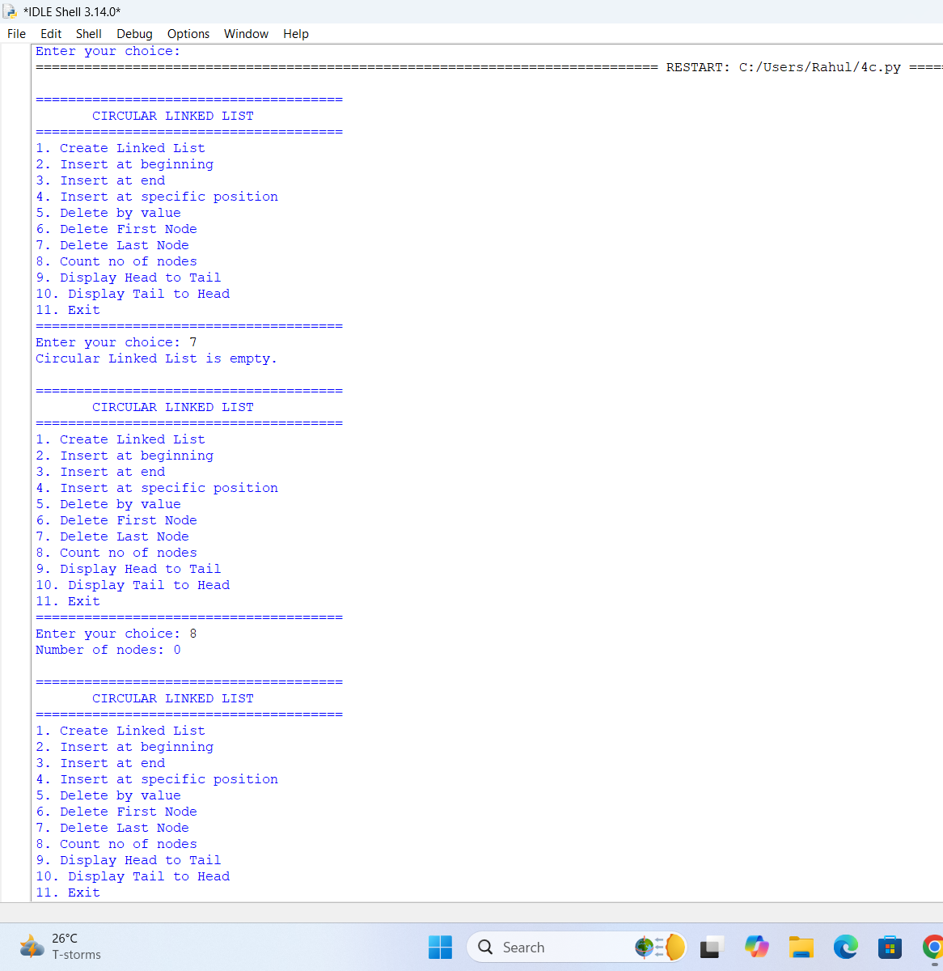

Explanation:
- The program implements a Circular Linked List using a Node class.
- Each node contains data and a next reference.
- The last node points back to the head, forming a circular structure.
- Nodes can be inserted at the beginning, end, or in a specific position.
- Nodes can be deleted by value, from the beginning, or from the end.
- The program counts the nodes and displays the list in head-to-tail and tail-to-head directions.
- A menu-driven approach is used to perform all operations.

Errors Table:

S.No | Errors | Correction
1 | def init(self, data): is incorrect | Change it to def __init__(self, data):
2 | def init(self): is incorrect | Change it to def __init__(self):
3 | if n <= 0: is written on the same line as the input statement | Write if n <= 0: on the next line with proper indentation.
4 | Main program statements after while True: are not indented | Indent the complete menu, input, and if-elif-else block inside while True:.
5 | print("Invalid choice.") is not properly indented under else: | Indent the print() statement by 4 spaces under else:.

WEEK – 5
5A.AIM: Write a Python Program Implement a Stack using Array also Implement the Stack Operations Such as Push, Pop,Peak also display the Stack Elements.
PROGRAM:
class Stack: def init(self): self.stack = []
# Push operation
def push(self, data):
self.stack.append(data)
print(data, "pushed into stack.")
# Pop operation
def pop(self):
if len(self.stack) == 0:
print("Stack Underflow.")
else:
data = self.stack.pop()
print(data, "popped from stack.")
# Peek operation
def peek(self):
if len(self.stack) == 0:
print("Stack is empty.")
else:
print("Top element:", self.stack[-1])
# Display stack
def display(self):
if len(self.stack) == 0:
print("Stack is empty.")
else:
print("Stack elements:")
for i in range(len(self.stack) - 1, -1, -1):
print(self.stack[i])
s = Stack()
while True: print ("\n========== STACK USING ARRAY ==========")
print ("1. Push")
print ("2. Pop")
print("3. Peek")
print ("4. Display")
print ("5. Exit")
print ("=======================================")
choice = int(input ("Enter your choice: "))
if choice == 1:
data = int(input ("Enter data: "))
s.push(data)
elif choice == 2:
s.pop()
elif choice == 3:
s.peek()
elif choice == 4:
s.display()
elif choice == 5:
print ("Program terminated.")
break
else:
print("Invalid choice.")

OUTPUT:
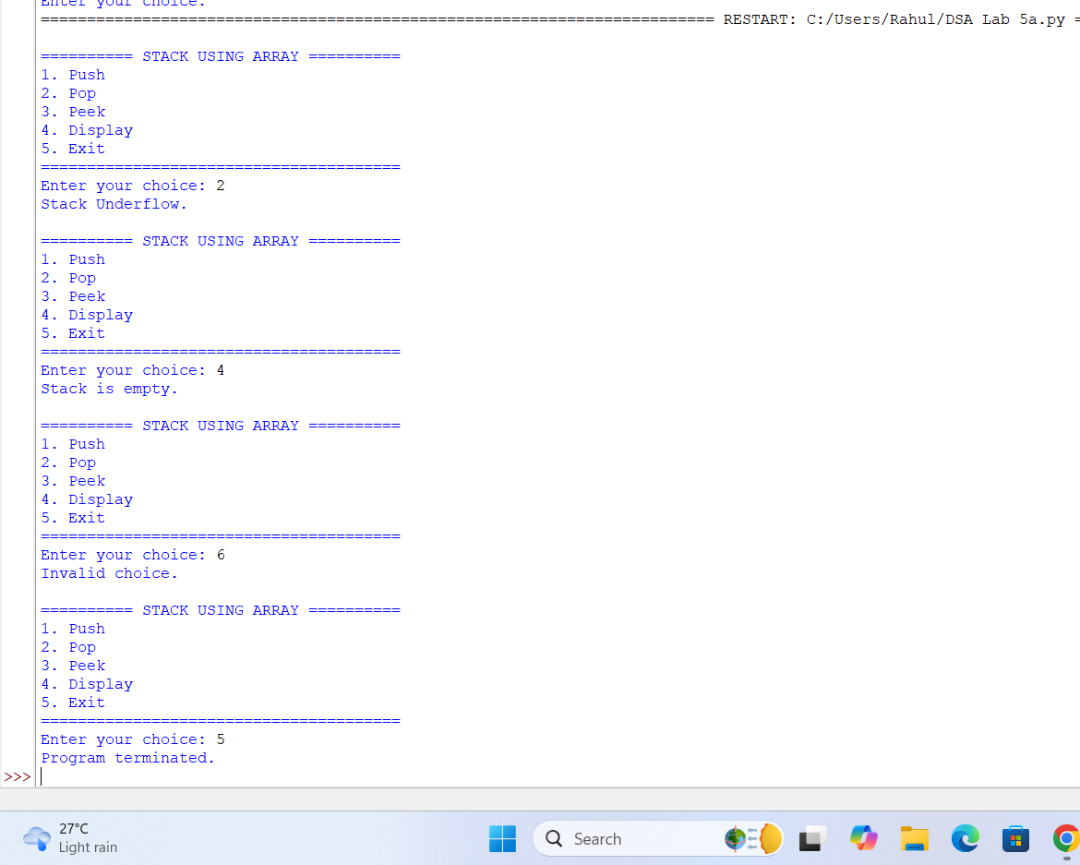

Explanation:
- Stack Creation:
The Stack class creates a stack using a Python list called self.stack.
- Push Operation:
The push() function adds a new element to the top of the stack using append().
- Pop Operation:
The pop() function removes the top element using pop(). If the stack is empty, it displays "Stack Underflow."
- Peek and Display:
The peek() function shows the top element without removing it, while display() prints all stack elements from top to bottom.
- Menu-Driven Program:
The main program uses a menu to allow the user to perform Push, Pop, Peek, Display, and Exit operations repeatedly.
Error Table:
S.NO | Errors | Correction
1. | def **init**(self): is incorrect | Change to def __init__(self):
2. | class Stack: def __init__(self): is written on the same line | Write class Stack: and the __init__() method on separate lines with proper indentation.
3. | Statements after while True: are not properly indented | Indent the entire menu and choice-handling code inside the while True: loop.
4. | print("2. Pop"), print("4. Display"), etc. have inconsistent indentation | Use consistent 4-space indentation for all menu statements.
5. | if choice == 1, elif, and else blocks are outside the while loop due to indentation | Indent the complete if-elif-else block inside while True:.

5B).AIM: Write a Python Program Implement a Stack using Linked List also Implement the Stack Operations Such as Push, Pop,Peak also display the Stack Elements.
PROGRAM:
class Node: def init(self, data): self.data = data self.next = None
class Stack: def init(self): self.top = Non# Push operation
def push(self, data):
new_node = Node(data)
new_node.next = self.top
self.top = new_node
print(data, "pushed into stack.")
# Pop operation
def pop(self):
if self.top is None:
print("Stack Underflow.")
else:
data = self.top.data
self.top = self.top.next
print(data, "popped from stack.")
# Peek operation
def peek(self):
if self.top is None:
print("Stack is empty.")
else:
print("Top element:", self.top.data)
# Display operation
def display(self):
if self.top is None:
print("Stack is empty.")
else:
print("Stack elements:")
temp = self.top
while temp is not None:
print(temp.data)
temp = temp.next

Main Program
s = Stack()
while True: print("\n========== STACK USING LINKED LIST ==========") print("1. Push") print("2. Pop") print("3. Peek") print("4. Display") print("5. Exit") print("=============================================")
choice = int(input("Enter your choice: "))
if choice == 1:
data = int(input("Enter data: "))
s.push(data)
elif choice == 2:
s.pop()
elif choice == 3:
s.peek()
elif choice == 4:
s.display()
elif choice == 5:
print("Program terminated.")
break
else:
print("Invalid choice.")

OUTPUT:
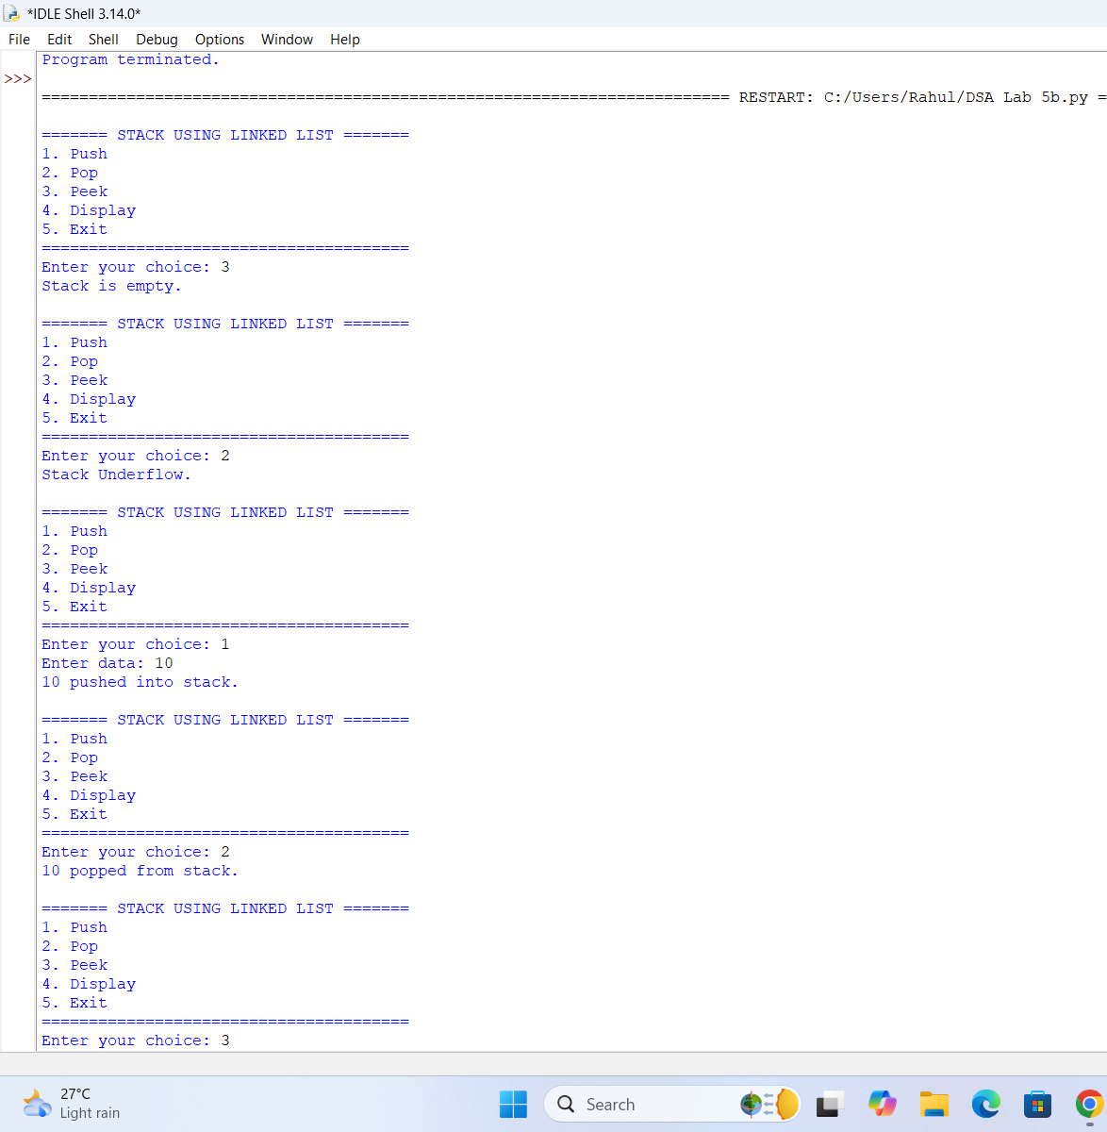x

Explanation:
- Node Creation:
Each stack element is stored in a node containing data and a next pointer.
- Push Operation:
A new node is created and inserted at the top of the stack.
- Pop Operation:
The top node is removed and top is moved to the next node. If there is no node, Stack Underflow is displayed.
- Peek Operation:
The peek() operation displays the top element without removing it.
- Display Operation:
The display() function traverses the linked list from top to None and displays all stack elements.
Error Table:
S.NO | Errors | Correction
1. | Writing def init() instead of the constructor | Use def __init__(self):
2. | Node class is not properly indented | Keep __init__() inside the Node class.
3. | new_node.next is not connected to the current top | Use new_node.next = self.top.
4. | Pop operation does not update the top pointer | Use self.top = self.top.next.
5. | Menu and if-elif statements are not properly indented inside while True | Maintain proper 4-space indentation inside the loop.

WEEK – 6
6A).AIM: Write a Python Program to implement Queue and its operations such as In queue, Dequeue, Peek, Display with a Menu-driven approach implement using Array and Linked List data structure.
PROGRAM:
queue = []

def enqueue () :
value = int(input("Enter element to insert: "))
queue.append(value)
print(value, "inserted into queue.")

def dequeue () :
if len(queue) == 0:
print("Queue is Empty.")
else:
value = queue.pop (0)
print(value, "deleted from queue.")

def peek () :
if len(queue) == 0:
print("Queue is Empty.")
else:
print("Front element is:", queue[0])

def display ():
if len(queue) == 0:
print("Queue is Empty.")
else:
print("Queue elements are:", queue)
while True:
print("\n--- QUEUE USING ARRAY ---")
print("1. Enqueue")
print("2. Dequeue")
print("3. Peek")
print("4. Display")
print("5. Exit")

choice = int(input("Enter your choice: "))

if choice == 1:
enqueue ()

elif choice == 2:
dequeue ()

elif choice == 3:
peek ()

elif choice == 4:
display ()

elif choice == 5:
print("Program terminated.")
break
else:
print("Invalid choice!")
OUTPUT:
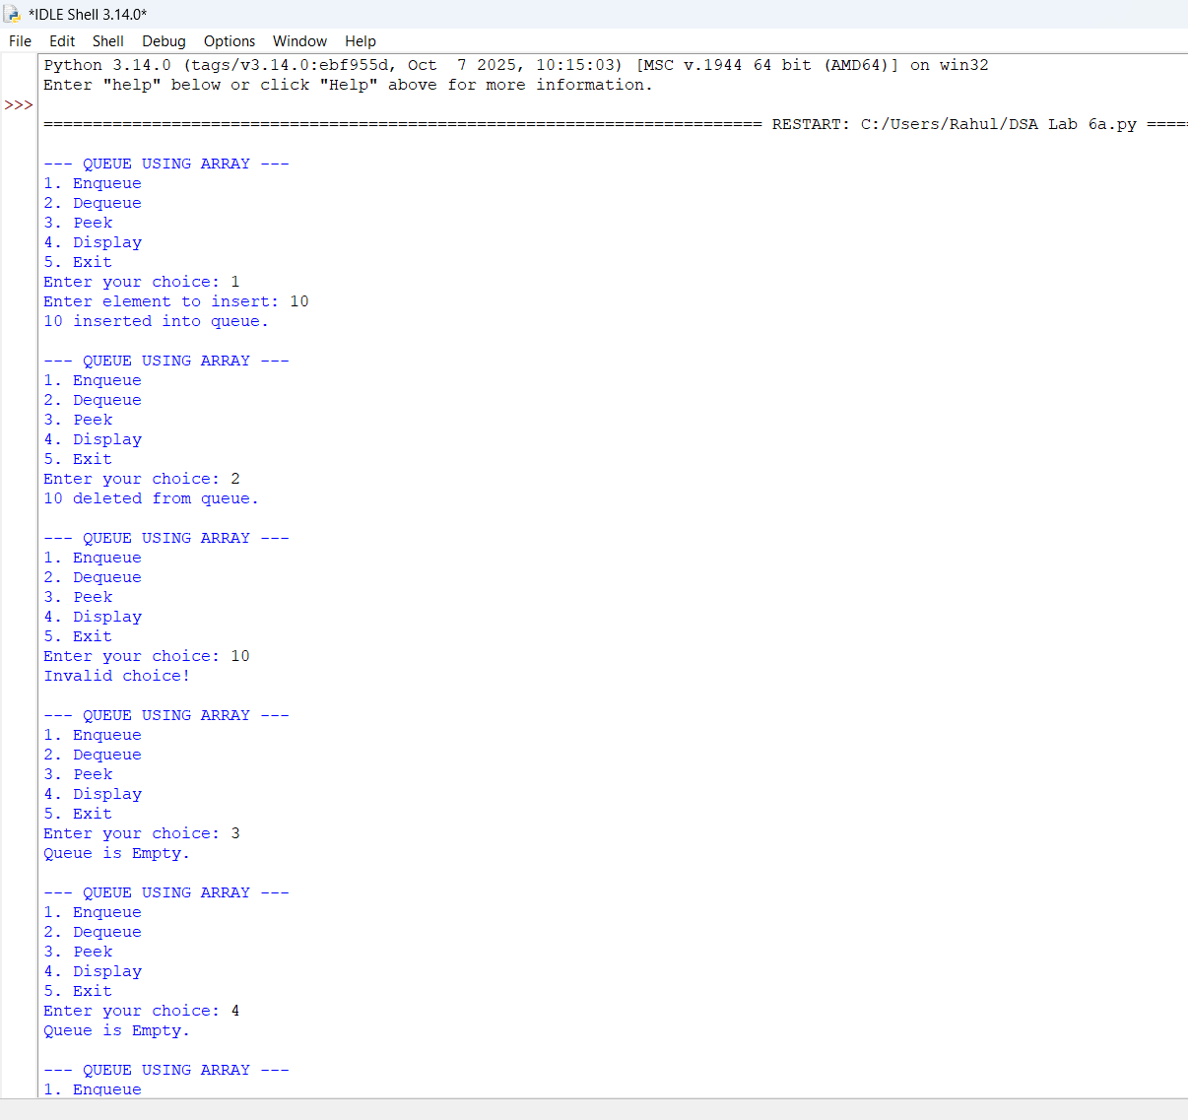
Explanation:
1)Queue Initialization:queue = [] creates an empty list to store queue elements. The queue follows FIFO (First In, First Out).
2)Enqueue Operation: The enqueue() function takes an integer from the user and uses queue.append(value) to insert it at the rear/end of the queue.
3)Dequeue Operation: The dequeue() function removes the front element using queue.pop(0). If the queue is empty, it displays "Queue is Empty."
4)Peek and Display Operations: peek () shows the front element without removing it, using queue[0]. The display() function prints all the elements currently present in the queue.
5)Menu-Driven Program: The While True loop repeatedly displays a menu. The user can choose Enqueue, Dequeue, Peek, Display, or Exit. Choosing 5 terminates the program.
Error Table:
S.NO | Error | Correction
1 | queue.pop (0) has unnecessary space before (. | Use queue.pop(0) for cleaner syntax.
2 | No validation for non-integer input. | Use try-except to handle invalid input.
3 | choice = int(input(...)) causes an error if the user enters a letter. | Handle invalid input using try-except ValueError.
4 | The queue uses pop(0), which is slower for large queues. | Use collections.deque and popleft() for efficient deletion.
5 | The program does not have a maximum queue size. | If a fixed-size queue is required, check the queue size before append().

6B).AIM: Write a Python Program to implement Queue and its operations such as In queue, Dequeue, Peek, Display with a Menu-driven approach implement using Circular Queue.
PROGRAM:
MAX = 5
queue = [None] * MAX
front = -1
rear = -1

def enqueue () :
global front , rear

if (real + 1) % MAX == front:
print("Queue is Full.")
return

value = int(input("Enter element to insert: "))

if front == -1:
front = 0
rear = 0
else:
rear = (rear + 1) % MAX

queue[rear] = value
print(value, "inserted into queue.")

def dequeue () :
global front, rear

if front == -1:
print("Queue is Empty.")
return

value = queue[front]

if front == rear:
front = -1
rear = -1
else:
front = (front + 1) % MAX

print(value, "de;eted from queue.")

def peek():
if front == -1:
print("Queue is Empty.")
return

def display():
if front == -1:
print("Queue is Elements.")
return

print("Queue elements are:",end=" ")

i = front

while True:
print(queue[i], end=" ")

if i == rear:
break

i = (i + 1) % MAX

print()

while True:
print("\n--- CIRCULAR QUEUE USING ARRAY ---")
print("1.Enqueue")
print("2.Dequeue")
print("3.Peek")
print("4.Display")
print("5.Exit")

choice = int(input("Enter your choice: "))

if choice == 1:
enqueue()

elif choice == 2:
dequeue()

elif choice == 3:
peek ()

elif choice == 4:
display()

elif choice == 5:
print("Program terminated.")
break
else:
print("Invalid choice!")
OUTPUT:
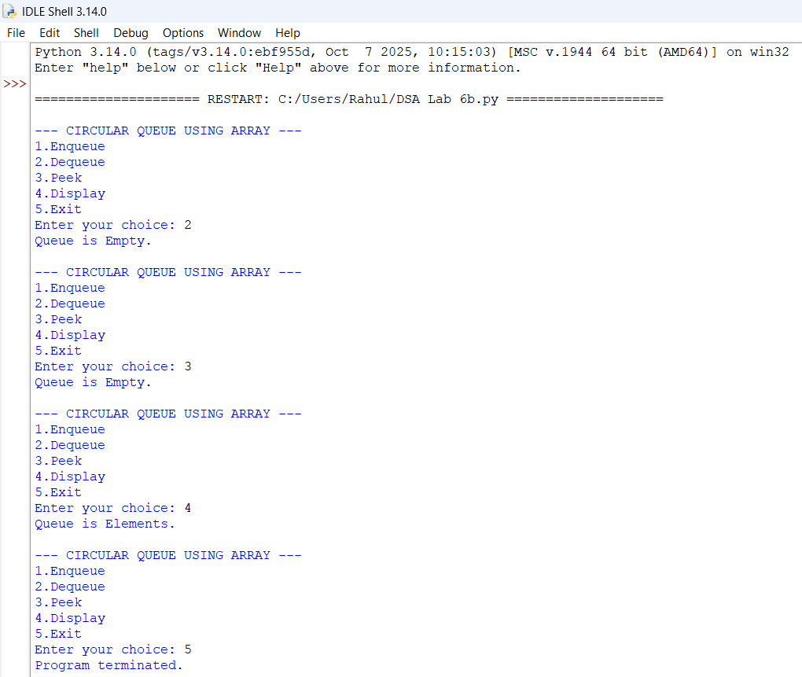

Explanation:
1)Queue Initialization: MAX = 5 sets the maximum queue size. queue = [None] * MAX creates an array of 5 positions, while front and rear keep track of the first and last elements.
2)Enqueue Operation: The enqueue() function inserts an element at the rear. It uses (rear + 1) % MAX so that the rear can move back to the beginning of the array, making it a circular queue.
3)Dequeue Operation: The dequeue() function removes the element at front. After deletion, front is moved forward using (front + 1) % MAX. If the last element is removed, both front and rear are reset to -1.
4)Peek and Display Operations: peek() is intended to show the front element without deleting it. display() starts from front and uses a loop to print all elements until it reaches rear.
5)Menu-Driven Program: The while True loop repeatedly displays options for Enqueue, Dequeue, Peek, Display, and Exit. The user's choice determines which queue operation is performed.
Errors Table:
S.No | Error | Correction
1 | real is used instead of rear in the full-condition check. | Change real to rear: if (rear + 1) % MAX == front:
2 | peek() does not print the front element when the queue is not empty. | Add print("Front element is:", queue[front]) after the empty check.
3 | "Queue is Elements." is incorrect in display(). | Change it to "Queue is Empty."
4 | "de;eted from queue." contains a spelling error. | Change it to "deleted from queue."
5 | int(input()) can cause a ValueError if the user enters non-numeric input. | Use try-except ValueError to handle invalid input.

WEEK – 7
7A.1).AIM: Write a Python Program to implement a binary tree using an array with all of its operations
PROGRAM:
MAX = 100
tree = [None] * MAX
def insert(value, index=0): if index >= MAX: print("Tree is full.") return
if tree[index] is None:
tree[index] = value
print(value, "inserted.")
return
if value < tree[index]:
insert(value, 2 * index + 1)
else:
insert(value, 2 * index + 2)
def inorder(index=0): if index >= MAX or tree[index] is None: return
inorder(2 * index + 1)
print(tree[index], end=" ")
inorder(2 * index + 2)
def preorder(index=0): if index >= MAX or tree[index] is None: return
print(tree[index], end=" ")
preorder(2 * index + 1)
preorder(2 * index + 2)
def postorder(index=0): if index >= MAX or tree[index] is None: return
postorder(2 * index + 1)
postorder(2 * index + 2)
print(tree[index], end=" ")
def level_order(): for i in range(MAX): if tree[i] is not None: print(tree[i], end=" ")
def search(value, index=0): if index >= MAX or tree[index] is None: return False
if tree[index] == value:
return True
if value < tree[index]:
return search(value, 2 * index + 1)
else:
return search(value, 2 * index + 2)
def count_nodes(index=0): if index >= MAX or tree[index] is None: return 0
return 1 + count_nodes(2 * index + 1) + count_nodes(2 * index + 2)
def count_leaf_nodes(index=0): if index >= MAX or tree[index] is None: return 0
left = 2 * index + 1
right = 2 * index + 2
if (left >= MAX or tree[left] is None) and \
(right >= MAX or tree[right] is None):
return 1
return count_leaf_nodes(left) + count_leaf_nodes(right)
def height(index=0): if index >= MAX or tree[index] is None: return 0
left_height = height(2 * index + 1)
right_height = height(2 * index + 2)
return 1 + max(left_height, right_height)
def display():
print ("\nArray Representation:")
for i in range(MAX):
if tree[i] is not None:
print ("Index", i, ":", tree[i])
while True:
print("\n===== BINARY TREE USING ARRAY =====")
print("1. Insert")
print("2. Inorder Traversal")
print("3. Preorder Traversal")
print("4. Postorder Traversal")
print("5. Level Order Traversal")
print("6. Search")
print("7. Count Nodes")
print("8. Count Leaf Nodes")
print("9. Height")
print("10. Display Array")
print ("11. Exit")
choice = int(input("Enter your choice: "))
if choice == 1:
value = int(input("Enter value: "))
insert(value)
elif choice == 2:
print("Inorder:", end=" ")
inorder()
print()
elif choice == 3:
print("Preorder:", end=" ")
preorder()
print()
elif choice == 4:
print("Postorder:", end=" ")
postorder()
print()
elif choice == 5:
print("Level Order:", end=" ")
level_order()
print()
elif choice == 6:
value = int(input("Enter value to search: "))
if search(value):
print("Value found.")
else:
print("Value not found.")
elif choice == 7:
print("Total nodes:", count_nodes())
elif choice == 8:
print("Leaf nodes:", count_leaf_nodes())
elif choice == 9:
print("Height:", height())
elif choice == 10:
display()
elif choice == 11:
print("Program terminated.")
break
else:
print("Invalid choice.")
OUTPUT: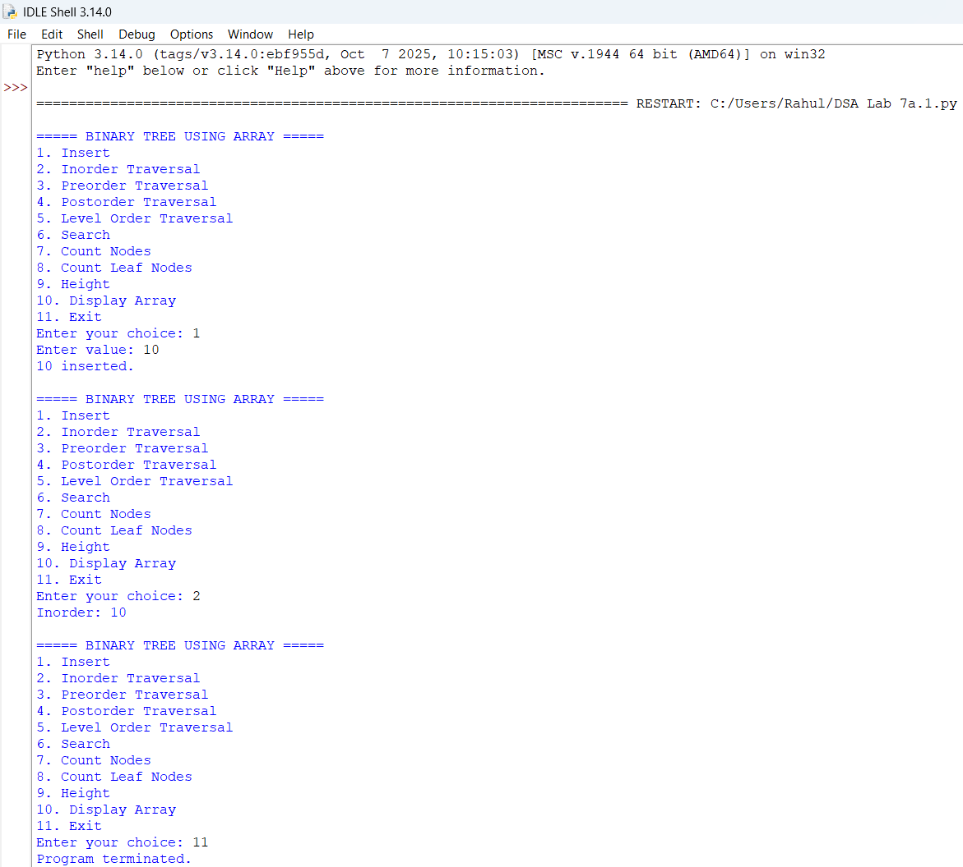

Explanation:
- Array Representation: The binary tree is stored in an array, where the root node is placed at index 0. For a node at index i, its left child is at 2i + 1 and the right child is at 2i + 2.
- Insertion: The insert () function adds elements to the tree. In this program, smaller values are placed in the left subtree and larger values in the right subtree.
- Tree Traversals: The program supports order, preorder, post order, and level-order traversal to visit all nodes in different orders.
- Searching and Counting: The program can search for a particular value and calculate the total number of nodes and leaf nodes in the tree.
- Other Operations: The program calculates the height of the tree and displays the array of representation. A menu-driven approach allows the user to select different operations.
Error Table:
S.No | Error | Correction
1 | Using the wrong index for the left child. | Use 2 * index + 1 for the left child.
2 | Using the wrong index for the right child. | Use 2 * index + 2 for the right child.
3 | Accessing an array index beyond MAX. | Check if index >= MAX before accessing the array.
4 | Not checking whether an array position is None. | Check if tree[index] is None before processing the node.
5 | Forgetting to initialize the array. | Initialize it using tree = [None] * MAX.

7A.2).AIM: Write a Python Program to implement a binary tree using an linked list with all of its operations
PROGRAM:
class Node:
def __init__(self, data):
self.data = data
self. Left = None
self. Right = None
class BinaryTree:
def __init__(self):
self.root = None
def insert(self, value):
new_node = Node(value)
if self.root is None:
self.root = new_node
print(value, "inserted.")
return
queue = [self.root]
while queue:
current = queue.pop(0)
if current.left is None:
current.left = new_node
print(value, "inserted.")
return
else:
queue.append(current.left)
if current.right is None:
current.right = new_node
print(value, "inserted.")
return
else:
queue.append(current.right)
def inorder(self, node):
if node is None:
return
self.inorder(node.left)
print(node.data, end=" ")
self.inorder(node.right)
def preorder(self, node):
if node is None:
return
print(node.data, end=" ")
self.preorder(node.left)
self.preorder(node.right)
def postorder(self, node):
if node is None:
return
self.postorder(node.left)
self.postorder(node.right)
print(node.data, end=" ")
def level_order(self):
if self.root is None:
return
queue = [self.root]
while queue:
current = queue.pop(0)
print(current.data, end=" ")
if current.left is not None:
queue.append(current.left)
if current.right is not None:
queue.append(current.right)
def search(self, node, value):
if node is None:
return False
if node.data == value:
return True
return (self.search(node.left, value) or
self.search(node.right, value))
def count_nodes(self, node):
if node is None:
return 0
return (1 +
self.count_nodes(node.left) +
self.count_nodes(node.right))
def count_leaf_nodes(self, node):
if node is None:
return 0
if node.left is None and node.right is None:
return 1
return (self.count_leaf_nodes(node.left) +
self.count_leaf_nodes(node.right))
def height(self, node):
if node is None:
return 0
left_height = self.height(node.left)
right_height = self.height(node.right)
return 1 + max(left_height, right_height)
def minimum(self, node):
if node is None:
return None
while node.left is not None:
node = node.left
return node.data
def maximum(self, node):
if node is None:
return None
while node.right is not None:
node = node.right
return node.data
tree = BinaryTree()
while True:
print("\n===== BINARY TREE USING LINKED LIST =====")
print("1. Insert")
print("2. Inorder Traversal")
print("3. Preorder Traversal")
print("4. Postorder Traversal")
print("5. Level Order Traversal")
print("6. Search")
print("7. Count Nodes")
print("8. Count Leaf Nodes")
print("9. Height")
print("10. Minimum")
print("11. Maximum")
print("12. Exit")
choice = int(input("Enter your choice: "))
if choice == 1:
value = int(input("Enter value: "))
tree.insert(value)
elif choice == 2:
print("Inorder:", end=" ")
tree.inorder(tree.root)
print()
elif choice == 3:
print("Preorder:", end=" ")
tree.preorder(tree.root)
print()
elif choice == 4:
print("Postorder:", end=" ")
tree.postorder(tree.root)
print()
elif choice == 5:
print("Level Order:", end=" ")
tree.level_order()
print()
elif choice == 6:
value = int(input("Enter value to search: "))
if tree.search(tree.root, value):
print("Value found.")
else:
print("Value not found.")
elif choice == 7:
print("Total nodes:", tree.count_nodes(tree.root))
elif choice == 8:
print("Leaf nodes:", tree.count_leaf_nodes(tree.root))
elif choice == 9:
print("Height:", tree.height(tree.root))
elif choice == 10:
print("Minimum:", tree.minimum(tree.root))
elif choice == 11:
print("Maximum:", tree.maximum(tree.root))
elif choice == 12:
print("Program terminated.")
break
else:
print("Invalid choice.")

OUTPUT: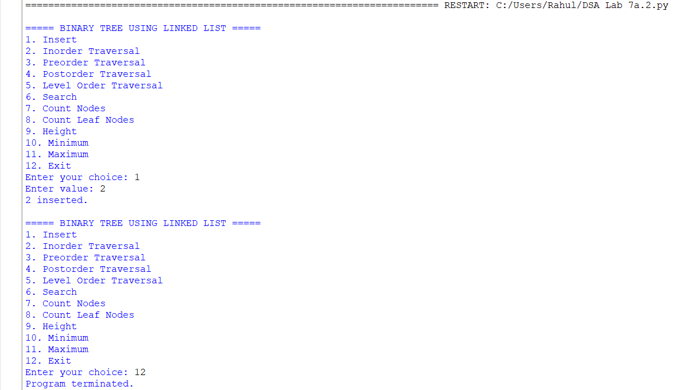
Explanation:
- Node Structure: Each tree node is created using a Node class containing three parts: data, left pointer, and right pointer.
- Insertion: The insert() function adds nodes using level-order insertion, filling the left and right positions of each level before moving to the next level.
- Tree Traversals: The program provides inorder, preorder, postorder, and level-order traversal to display the elements of the binary tree.
- Searching and Counting: The program can search for a value and calculate the total number of nodes and leaf nodes using recursive functions.
- Additional Operations: The program calculates the height of the tree and finds the minimum and maximum values. A menu-driven system allows the user to perform each operation easily.

Error Table:
S.No | Error | Correction
1 | Creating a node without initializing its child pointers. | Set self.left = None and self.right = None in the constructor.
2 | Accessing node.data when node is None. | Add if node is None: return before accessing the node.
3 | Forgetting to set the root when the tree is empty. | Use if self.root is None: self.root = new_node.
4 | Not adding existing child nodes to the queue during insertion. | Add them using queue.append(current.left) and queue.append(current.right).
5 | Calling traversal without passing the root node. | Call it as tree.inorder(tree.root), tree.preorder(tree.root), etc.

WEEK-8
8A).AIM: Write a Program to implement Binary Search Tree with it's operations
Transversals also.
Program:
class Node:
def _init_(self, data):
self.data = data
self.left = None
self.right = None
def insert(root, data): if root is None: return Node(data)
if data < root.data:
root.left = insert(root.left, data)
elif data > root.data:
root.right = insert(root.right, data)
return root
def search(root, key): if root is None or root.data == key: return root
if key < root.data:
return search(root.left, key)
return search(root.right, key)
def find_min(root): while root.left: root = root.left return root
def delete(root, key): if root is None: return None
if key < root.data:
root.left = delete(root.left, key)
elif key > root.data:
root.right = delete(root.right, key)
else:
if root.left is None:
return root.right
if root.right is None:
return root.left
temp = find_min(root.right)
root.data = temp.data
root.right = delete(root.right, temp.data)
return root
def inorder(root):
if root:
inorder(root.left)
print(root.data, end=" ")
inorder(root.right)
root = None
values = [50, 30, 70, 20, 40, 60, 80]
for value in values:
root = insert(root, value)
print("BST Inorder Traversal:")
inorder(root)
key = 40
if search(root, key):
print("\n", key, "found in BST")
else:
print("\n", key, "not found in BST")
root = delete(root, 30)
print("After deleting 30:")
inorder(root)
print()
OUTPUT:
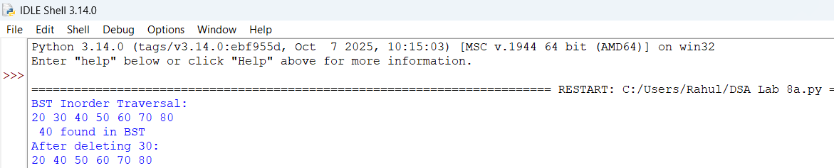Explanation:
1. Node Creation: The Node class stores data and references to the left and right child nodes.
2. Insertion: The insert() function adds elements to the BST. Smaller values go to the left, and larger values go to the right.
3. Searching: The search() function checks whether a given value exists in the tree by comparing it with each node.
4. Deletion: The delete() function removes a node from the BST. It handles nodes with zero, one, or two children.
5. Inorder Traversal: The inorder() function visits the left subtree, root, and right subtree, displaying the elements in ascending order.

Error Table:
S.No | Error | Explanation
1. | Not updating root | Always use root = insert(root, value) and root = delete(root, key) because these functions may return a new root.
2. | Searching for a missing value | search() returns None when the key does not exist. Your if search(root, key) check handles this correctly.
3. | Inserting duplicate values | insert() ignores duplicates because neither comparison is true when the values are equal. This is intentional behavior.
4. | Deleting a node with two children | Simply removing the node could break the BST structure. Your code correctly uses find_min() to find its inorder successor.
5. | Empty-tree minimum lookup | Calling find_min(None) directly would cause an error. Call it only when the subtree is non-empty, as your deletion code does.

WEEK-9
9A).AIM: Write a Program to implement AVL Tree with it's operations
Transversals also.
Program:
class Node:
Def_init_(self, data):
self.data = data
self.left = None
self.right = None
self.height = 1
def height(node):
if node is None:
return 0
return node.height
def balance_factor(node):
if node is None:
return 0
return height(node.left) - height(node.right)
def right_rotate(y):
x = y.left
t2 = x.right
x.right = y
y.left = t2
y.height = 1 + max(height(y.left), height(y.right))
x.height = 1 + max(height(x.left), height(x.right))
return x
def left_rotate(x):
y = x.right
t2 = y.left
y.left = x
x.right = t2
x.height = 1 + max(height(x.left), height(x.right))
y.height = 1 + max(height(y.left), height(y.right))
return y
def insert(root, data):
if root is None:
return Node(data)
if data < root.data:
root.left = insert(root.left, data)
elif data > root.data:
root.right = insert(root.right, data)
else:
return root
root.height = 1 + max(height(root.left), height(root.right))
bf = balance_factor(root)
if bf > 1 and data < root.left.data:
return right_rotate(root)
if bf < -1 and data > root.right.data:
return left_rotate(root)
if bf > 1 and data > root.left.data:
root.left = left_rotate(root.left)
return right_rotate(root)
if bf < -1 and data < root.right.data:
root.right = right_rotate(root.right)
return left_rotate(root)
return root
def search(root, key): if root is None or root.data == key: return root
if key < root.data:
return search(root.left, key)
return search(root.right, key)
def find_min(root): while root.left: root = root.left return root
def delete(root, key): if root is None: return None
if key < root.data:
root.left = delete(root.left, key)
elif key > root.data:
root.right = delete(root.right, key)
else:
if root.left is None:
return root.right
elif root.right is None:
return root.left
temp = find_min(root.right)
root.data = temp.data
root.right = delete(root.right, temp.data)
if root is None:
return None
root.height = 1 + max(height(root.left), height(root.right))
bf = balance_factor(root)
if bf > 1 and balance_factor(root.left) >= 0:
return right_rotate(root)
if bf > 1 and balance_factor(root.left) < 0:
root.left = left_rotate(root.left)
return right_rotate(root)
if bf < -1 and balance_factor(root.right) <= 0:
return left_rotate(root)
if bf < -1 and balance_factor(root.right) > 0:
root.right = right_rotate(root.right)
return left_rotate(root)
return root
def inorder(root):
if root:
inorder(root.left)
print(root.data, end=" ")
inorder(root.right)
root = None
values = [10, 20, 30, 40, 50, 25]
for value in values:
root = insert(root, value)
print("AVL Inorder Traversal:")
inorder(root)
key = 25
if search(root, key):
print("\n", key, "found in AVL tree")
else:
print("\n", key, "not found in AVL tree")
root = delete(root, 40)
print("After deleting 40:")
inorder(root)
print()
OUTPUT: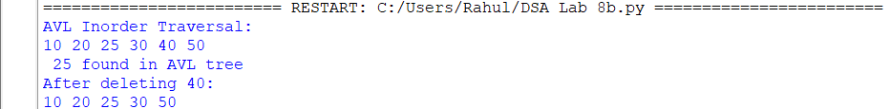

Explanation:
1. Node Creation and Height: The Node class stores data, left and right child references, and the height of each node.
2. Height and Balance Factor: The height() function calculates a node's height, while balance_factor() checks whether the tree is balanced.
3. Insertion and Rotations: The insert() function adds values to the AVL tree and performs LL, RR, LR, or RL rotations to maintain balance.
4. Searching and Deletion: The search() function finds a value, while delete() removes a node and rebalances the tree using rotations when necessary.
5. Inorder Traversal and Output: The inorder() function displays the elements in ascending order. The main program inserts values, searches for 25, deletes 40, and prints the updated tree.
Error Table:
S.No. | Error / Limitation | Explanation / Solution
1. | Incorrect height update | If node heights are not updated after rotations, the balance factor becomes incorrect. Update heights after every rotation.
2.. | Incorrect balance factor | Using height(right) - height(left) instead of height(left) - height(right) reverses the rotation conditions.
3. | Missing rotation cases | Handling only LL and RR cases can leave the tree unbalanced. Handle all four cases: LL, RR, LR, and RL.
4. | Root not updated | If the root changes after insertion, deletion, or rotation, assign the returned node to root.
5. | Duplicate values | The insertion function ignores duplicate values using else: return root. Add separate duplicate-handling logic if duplicates are required.

WEEK-10
10A). AIM: Write a python program to implement hashing using seperate chaining linear and Quardtic Probic.
PROGRAM:
size = 10
def chaining(keys):
table = [[] for _ in range(size)]
for key in keys:
table [key % size]. append(key)
print ("Separate Chaining:", table)

def linear(keys):
table = [-1] * size
for key in keys:
i = key % size
while table[i] != -1:
i = (i + 1) % size
table[i] = key
print("Linear Probing:", table)

def quadratic(keys):
table = [-1] * size
for key in keys:
h = key % size
for i in range(size):
j = (h + i * i) % size
if table[j] == -1:
table[j] = key
break
else:
print("Table full for key:", key)
print("Quadratic Probing:", table)

keys = list(map(int, input("Enter keys: ").split()))

chaining(keys)
linear(keys)
quadratic(keys)
OUTPUT:
Explanation:
1)Hash Function: key % size calculates the index where a key should be stored.
2)Separate Chaining: Uses a list at each index to store multiple keys when collisions occur.
3)Linear Probing: If a position is occupied, it checks the next position using (i + 1) % size.
4)Quadratic Probing: If a collision occurs, it checks positions using (h + i*i) % size.
5)Display: The program prints the hash table for all three methods so we can compare collision handling.

Error Table:
S.No. | Error / Problem | Solution
1. | IndexError: list index out of range | Use modulo % size to keep the index within the table.
2. | ValueError: invalid literal | Enter only integer keys.
3. | Infinite loop in linear probing | Check whether the hash table is full before inserting.
4. | Key not inserted in quadratic probing | Check all possible probes and report if insertion fails.
5. | Duplicate keys inserted | Allow duplicates or add a condition to reject them, depending on the requirement.

